BIO-DATA
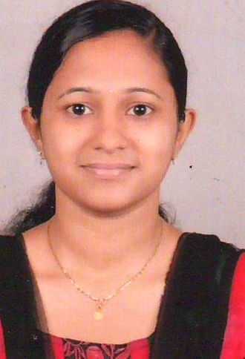
NIVYA JOSE
Social Worker

Personal information
Permanent Address: Kanayankel Thekkethil (H) Mevada P.O., Mevada, Kottayam (Dt), Kerala, Pin: 686573
Mob: 7025344039
Email id: nivyajose13@gmail.com
Date of birth: 13 June 1993
Academic Qualifications
- Specalized in Accounting and Finance (September 2017 – March 2018)
Learn Key Institute, Malta (Europe)
- MSW (Specialized in Medical and Psychiatry)- 2015
Kannur University, Kannur
- B.A. English literature(2013)
Mahatma Gandhi University, Kottayam
- Higher Secondary (2010)
State Board
- S.S.L.C (2008)
State Board

Employment History
- Social Worker
Ujjawala scheme for Prevention of trafficking(Rehabilitation), a project under Ministry of Women and Child Development, Government of India in St.Vincent’s Home, Calicut ( August 2015- July 2017) Full-time
Duties Included:
- Documentation Work
- Counselling
- Conducting awareness classes and life skill training programs for both the victims of abuse and vulnerable groups
- Take part actively in the process of Rehabilitation of victims into family and community
- Supervision of trainees

- Para Legal Volunteer
Para Legal Volunteer in District Legal Service Authority, Thalassery, Kerala (November 2013 – May 2015) Part Time
- visit the Police Station and jails and ensure that the arrested person gets legal assistance
- visit children's homes/observation homes
- organizing legal awareness class
- A daily report submitted to the Secretary, DLSA

Internships and Training
- ST.VINCENT’S HOME in Calicut for 1 month in May 2015
- NARAYANA HRUDAYALAYA, Bangalore for 1 month in March 2015
- CHAITHANYA MENTAL HEALTH CARE CENTRE, Pune,Maharashtra for 1 month in November 2014
- COMPETENCY TRAINING PROGRAMME in Padivayal, Wayanad, for 1 month in May 2014

Research
A Study on the Awareness of Sexuality among Adolescents Tribal Girls, Which Special Reference to Government High School, Aralam.Iritty,Kannur (Dt)Kerala

Certification programs, workshops and conferences attended
- Successfully completed three days training workshop on Promotion of Rural Employment and Marketing (PREM) for Entrepreneurship Development,18th -20th July 2016 at centre for Alternate Learning and Living, Chalakudy
- Actively participated in an one day Orientation Programme on Child Mental Health- Current Challenges held at Govt.Medical College, Kozhikode on 20th march 2016
- Participated in two days orientation programme for the managers of Care institutions Registered under Board of Control for the Orphanages and other Charitable Homes, organized by Department of Social Justice,Thiruvanathapuram,February 2016
- Participated in two day International Conference on “International Social Work: Crossing Borders, Building Bridges” organized by the Department of social work,De Paul Institute of science &Technology, Angamaly,Kerala and James Cook University, Australia
- Participated in two day National Seminar on “Nano Aspects in Social Work: Methods, Settings & Interventions” in St.Joseph’s College Pilathara, Kannur.
- Participated in two day National Conference on “Youth problems and Challenges” in Don Bosco Arts & Science College Angadikadavu, Kannur.
- Three Day Workshop On N.G.O. Management, Fund Rising and Project Proposal Writing, from 2nd – 4th September2014
- Sucessfully completed three months training workshop on EFT (Emotional Freedom Technique) organized by the P.G. Department of Social Work,Don Bosco Arts and Science College in collaboration with Bosco Institute of Energy Psychology,Monvila,Kulathoor,Trivandrum from May to July.
- One week training work shop on Creative and Expressive resources (Art Therapy)
Languages known
- Read- English, Hindi, Malayalam.
- Write- English, Hindi & Malayalam
- Speak- English & Malayalam

Technical skills
Knowledge in MS office & SPSS
Hobbies & Interests
Listening to Music, Watching Movies & Reading Books
Declaration
I hereby declare that the above written particulars are true to the best of my knowledge and belief.
Date: 03/08/2018
Place :Pala

