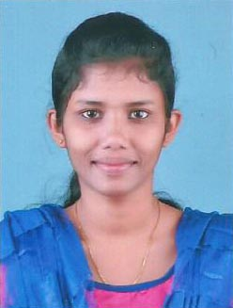
CURRICULUM VITAE

POST APPLIED FOR : MEDICAL LAB
TECHNICIAN
PERSONAL DETAILS
Name : VINNI WILSON
Father”s Name : Wilson
Age & Date of birth : 20, 07-03-1998
Sex : Female
Marital Status : Single
Religion : Christian, RCSC
Nationality : Indian
Place of Birth : Wayanad
Address : Vinni Wilson
Koyikkakudiyil (H)
Thrikkaipetta P.O
Wayanadu Dist., Pin-673577
Kerala State, India
Contact Number : 9656931871
Emai : vinniwilson1998@gmail.com
Languages Known : English & Malayalam

EDUCATIONAL QUALIFICATION
SSLC | March 2013 From Kerala State Board of Public Examinations
VHSC | March 2015 From Board of Vocational Higher Secondary Examination (Govt. of Kerala )

PROFESSIONAL QUALIFICATION
B.Sc Medical Laboratory Technology | Bharat College of Allied Health Sciences,Pala.

OTHER QUALIFCATION
Computer Education | Computer Basics

DECLARATION
The above mentioned information’s are true and correct to the best of my knowledge and belief.
Place: Wayanad
Date: 04/08/2018 VINNI WILSON

