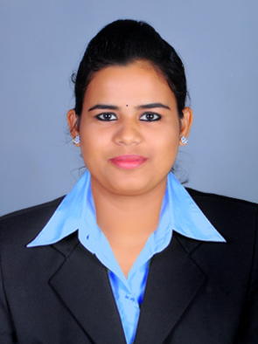
CURRICULUM VITAE

SILJA JOHNSON

D/O JOHNSON V.J
VAKAYIL HOUSE
P.O KAKKASSERY, THRISSUR
680511, KERALA, INDIA.
VAKAYIL

Contact No: 9496839836

Email: siljamaluz@gmail.com

Career Objective:

Finding a spot as a Hospital Administrator in a Health Care Facility in which I am able to use my experience and proficiency to bring benefit to the organization and to patients.

Professional Ability:

- Thorough knowledge in computer, Including the Word, Excel and PowerPoint.
- Taking care of budgeting, training, billing and hiring.
- Capability in typing fast without mistakes in grammar, spelling and punctuality.
- Planning and Management.
- Updating and processing of all documents.
- Updating & maintain the holiday, absence and training records of staff.
- Typing documents and preparing memos.

Professional Skill:

- Exceptional Communication skill with colleagues and patients.
- Excellent leadership Qualities.
- Managing the task and the time with remarkable efficiency.
- Highly competent, self-motivated and hardworking with the ability to rapidly learn and apply new skills.
- Ability to produce consistently accurate work even whilst under pressure.
- Strong organizational, administrative and analytical skills.

Professional Qualification:

- Master’s Degree from Calicut University in MHA (MASTER OF HOSPITAL ADMINISTRATION)
- Bachelor’s Degree from Calicut University in Bsc. Zoology

Internship & Projects:

- Rajagiri Hospital (NABH and JCI Accredited)
Aluva, Ernakulam, Kerala, India.
Operations Department – Major Project – 1 Month (02-05-2018 – 03-06-2018)
Topic – “A Study on In-Patient Satisfaction in Rajagiri Hospital”

- Kovai Medical Center and Hospital LTD. (NABH Accredited)
Coimbatore, Tamilnadu, India
Observation Study – 15 Days (13-12-2017-27-12-2017)

- Metropolitan Hosptial
Thrissur, Kerala, India
Observation Study – 15 Days (17-07-2017 – 03-08-2017)

- St. Joseph’s Hospital
Choondal, Thrissur, Kerala, India.
Organizational Study – 15 Days (19-12-2016 – 02-01-2017)

Leadership Experience:

- Organizer, National Conference Hospica en Masse’ 17 on 10th November, 2017 at Lulu International Convention Centre, Thrissur, Kerala, India. www.hospicaenmasse.com
- Executive Member, National Conference Hospica en Masse’ 16 on 15th October 2016 at Lulu International Convention Centre, Thrissur, Kerala, India.

Languages Skills:

- Fluent in English, Malayalam,Tamil and Hindi

Personal Profile

Nationality : Indian
Marital Status : Single
DOB : 21-11-1995
Passport No : MO196092
Date of Expiry : 15-07-2024

Declaration

I hereby declare that the particular stated above are true and correct to the best of my knowledge and belief.

Place : Thrissur SILJA JOHNSON

