RESUME
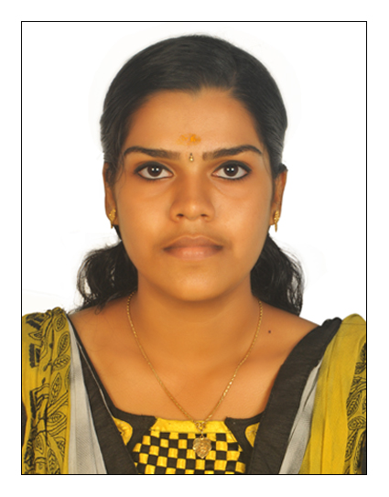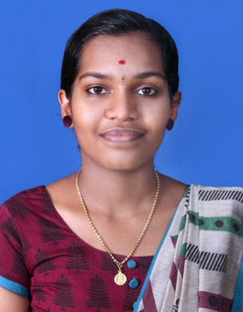
Anjana A.S.
Alekudiyil (H)
Ayavana P.O.
Muvattupuzha
PIN : 686668
Ernakulam(Dist)
E-mail :anjanaas868@gmail.com
Mob :+919961525685

CAREER OBJECTIVES

Anaesthesia technologist, skilled in various disciplines from general anesthesiology, to support hospital administration ensuring compliance to the hospital policies and procedures. I can give quality care to the patients as a member of the team.

ACADEMIC QUALIFICATIONS

COURSE | BOARD | INSTITUTION | PERCENTAGE OF MARKS | YEAR OF PASSING
DIPLOMA IN ANAESTHESIA AND CRITICAL CARE TECHNOLOGY | CHRISTIAN MEDICAL ASSOCIATION OF INDIA[CMAI] | LISIE MEDICAL INSTITUTION ERNAKULAM INDIA | 79.6% | 2018
PLUS-TWO | KERALA HIGHER SECONDARY BOARD | S.N.D.P HSS MUVATTUPUZHA | 78.4% | 2016
SSLC | KERALA BOARD OF SECONDARY SCHOOL | S.H.H.S. AYAVANA | 93.3% | 2014

DUTIES AND RESPONSIBILITIES
- Assisting anesthesiologist for providing various anesthesia techniques, central venous canulation, arterial line insertion, PA catheter insertion, intubation in peripheral area like trauma, emergency, CT, MRI , endoscopy room , and intensive care units.
- Monitoring anaesthetized patients during surgery and transportation. I have been trained in trauma team for bringing referred patients to our hospital from other hospital. Monitoring patients undergoing “labour Analgesia” in labour room.

SKILLS ABLE TO PERFORM
- I have work experience in different OTs such as Neuro surgery ,orthopedics surgery ,general surgery, ENT surgery, Urology, Nephrology , Renal transplant surgery, Oral and facio maxillary surgery, ophthalmic surgery, cardio thoracic surgery, Gastroenterology, gynecology.
- I have also got work experience in different ICUs in neurosurgery ICU , surgical ICU, medical ICU, transplant ICU, cardio thoracic ICU, coronary care unit, Neuro medical ICU, Nephro ICU, emergency medicine, neonatal ICU, Gynaec ICU, high dependency unit. I have also got practical experience in miscellaneous posting like X-ray department, ECG, labour room.

EQUIPMENTS HANDLED
- Anaesthesia Machines
- Anaesthesia Monitors
- Anaesthesia Ventilators
- ICU Ventilators
- Diathermies
- Vapourisers
- Syringe Pumps
- Fiberoptic bronchoscopes
- Bair hugger warming system
- Ultra sound machine (sonosyte)
- Various airway equipment like LMA, ILMA, Combitube, Double Lumen Tubes, flexo metallic tubes, nasal RAE tubes, Oral RAE Tubes, Micro Laryngeal Tubes
- Cricothyroidotomy set, tracheostomy set, stylet and bougie,ventilating bougie
- Various oral and nasal airways face masks.
- Laryngoscopes mackintosh,millers,maccoy,fiber optic and fiberless optic scopes
- Different breathing circuits like Jackson rees circuit,limbo and bain circuit
- Defibrillators Philips, BPL.

KEY STRENGTHS
- Strong commitment to standards of excellence in professional anesthesiology.
- Excellelent communication with others in the dissemination of information.
- Enjoys meeting of new challenges.
- Co-ordination with all levels of allied professionals.
- Able to manage all kind of emergency situation.

PERSONAL DETAILS

Date of Birth : 20-08-1997
Marital Status : Single
Nationality : Indian
Gender : Female
Languages : English and Malayalam
Contact Number : 9961525685
Email : anjanaas868@gmail.com

Notice Period :None

References : Furnish Upon Time

DECLARATION

I do hereby declare that the above-mentioned facts are true to best of my Knowledge and belief. Thanking you.
Yours faithfully,
ANJANA A.S.

