AMALA BABY
Mobile: 9747812045 (India) Email: kochusmaria@gmail.com

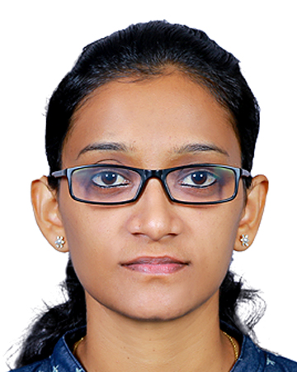

A challenging growth- oriented position in a progressive institution, where I could contribute to organization’s success- not only by my educational expertise but also through my innovative ideas and desire to achieve excellence in whatever I do.
SYNOPSIS

M.Sc in Medical and Surgical Nursing ( Specialized area- Neuroscience Nursing) from Kerala University of Health Sciences (KUHS), Kerala. Having 1 year and 2 months of work experience after B.Sc Nursing.

ACADEMIC

Sl No | Name of the Institution | Course and University | Year of Completion | Marks obtained
1 | RMHSS Vadavucode | Plus Two | 2009 | 66.83%
2 | Rukmini Shetty Memorial College of Nursing | B.Sc Nursing | 2013 | 63%
3 | MOSC College of Nursing | M.Sc Nursing | 2018 | 65.2%

KEY SKILLS

- Experienced in caring for medical patients
- Good nursing assessment skills
- Strong clinical competence and knowledge of nursing process
- Excellent documentation and communication skills
- Good organizational and critical thinking skills.
INDUSTRIAL EXPERIENCE

- Father Muller Medical College Hospital
Father Muller Road, Kankanady, Mangalore- 575 002, India
Tel: (0824) 2238000, 2436301-3, Email: muller@bsnl.in > Staff
Nurse in Medical and Surgical Department from 02/April/2014 to 30/June/2015.

TASK AND RESPONSIBILITIES

The main duties and responsibilities will include:
- Demonstrate and take re-demonstration of nursing procedures for staff nurses in hospital and students.
- Plan, coordinate care for patient in patient care unit.
- Provide quality nursing care to patients.
- Taught subjects like anatomy, foundation of nursing, medical surgical nursing, community health nursing & conduct the classes as per published in the curriculam schedules.
- Ensure that students have a good understanding of the class rules and performance standards as required for passing the grade.
RECOGNITIONS

- Part of organizing International Conference on Disaster Preparedness & Emergency Management at MOSC College of Nursing.
- Part of organizing OSCE in Psychiatric Nursing at MOSC College of Nursing.
- Participated in various nursing conferences at regional, national and international levels.

COMPUTER SKILLS
- Operating Systems: Windows 98, Windows 2000
- Packages : MS-Office, Internet Package
- Basic knowledge of SPSS v.23
PERSONAL VITAE

Date of Birth : 21-12-1991
Father’s Name : T.V Baby
Gender : Female
Marital Status : Not Married
Nationality : Indian
Permanent Address : Ms.Amala Baby
Thudinal (H), Vadavucode(P.O)
Puthencruz, Ernakulam, 682310

REFERENCES
1. Prof Dr.Sheela Shenai N A
Principal, College of Nursing, MOSC Medical College Hospital
Tel: 0484-3055660, 9446065249
Email: conmosckol2gmail.com
2. Mrs Susan Mathai
HOD in Medical Surgical Nursing, MOSC Medical College Hospital
Tel: 9961620614
3. Mrs Ninu Sophia
Assistant Professor (Medical Surgical Nursing)
MOSC Medical College Hospital
Tel: 9495532467

Declaration:
I hereby declare that the above information is true and correct up to my knowledge and beliefs and I bear the responsibility for the correctness of the above mentioned particulars.
Date:
Place: Ernakulam
Amala Baby

