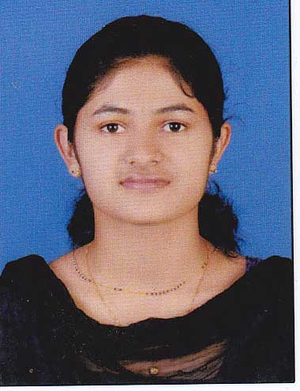
Monisha Joy
Kuttiyanimattathil House,
Kannickal PO, Manappady
Idukki
Kerala - 685589
E-mail: monishajoy9@gmail.com,
Phone: +91-9747460775

CAREER OBJECTIVE
To have a growth oriented and challenging career, where I can contribute my knowledge and skills to the organization and enhance my experience through continuous learning and teamwork.

ACADEMIC QUALIFICATION:
Course | University/Board |  | Institute | Year of Passing | Percentage  / CGPA
M.Sc DIETETICS AND FOOD SERVICE MANAGEMENT | IGNOU |  | ST. THERESA’S COLLEGE, ERNAKULAM | PURSING
B.Sc FOOD SCIENCE AND QUALITY CONTROL | M.G UNIVERSITY | ST. GEORGE’S COLLEGE |  | 2015 | 75%
SENIOR SECONDAY | KERALA STATE BOARD | ST. MARYS HIGHER SEC. SCHOOL |  | 2012 | 85%
HIGHER SECONDAY | KERALA STATE BOARD | ST. MARYS HIGHER SEC. SCHOOL |  | 2010 | 87%

INTERNSHIP TRAINING:
Organization | Duration | Description | Designation
Soorya Industries, Thodupuzha | 1 month | Conducted a project on getting value added products from cocoa mucilage. | Quality Control Trainee
Mangala Sea Foods, Cochin | 1 month | Trained to be a quality control inspector and scientist | Quality Control Trainee
CPD Milma, Alapuzha | 1 month | Trained to be a quality control inspector/scientist and production. | Production and Quality Control Trainee

MAIN PROJECT : Value added products from coca mucilage New product development : wine and vineger from rejected export quality cocoa beans.

EXTRACURRICULAR ACTIVITIES
- Working as a Part-time employee at Lake wood restaurant.
- An Event coordinator in college food fest – made common man aware of the adulterants used in food items.

TECHNICAL SKILLS

Have certificate of Training in advance Food Hygiene and HACCP based Food Safety Management System Level IV (ISO 22,000)

- Quality control and analysis: dairy products, ready-made goods, packaged food, Beverages, Food n Vegetables
- Product development: Jam-Jellies Marmalades
- Micro biology and Lab skills
- Marketing
- HACCP auditing
COMPUTER SKILLS
- Proficiency in Computers& having adequate exposure to computer applications in Dairy Industry – MS OFFICE
PERSONAL DETAILS
Date of Birth : 14-05-1995
Sex : female
Nationality : Indian
Marital Status : Married
Religion : Christian
Interests : Listening music, Reading book, Cooking, Stamp collection
Languages Known : Malayalam, English, Hindi, Tamil

REFERENCE :
Dr. Rahul Cyriac, Head of the Department, Food Science and Quality Control, St. Georges college, Aruvithura. E-mail: rahulcyriac@yahoo.co.in

DECLARATION
I hereby declare that the above mentioned information is correct up to my knowledge and I bear the responsibility for the correctness of the above mentioned particulars.

Monisha Joy
Place:
Date:

