RESUME
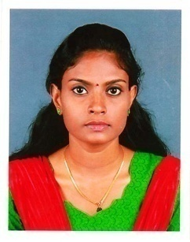  NANDINI BABURAJ  Contact Information  Address:  Edathumpadickal(H)  Pakkil (PO)  Kottayam-686012  Mo : 7034170860  8929957759  Email:  nandininandu5413@gmail.com  Personal Data  Date of Birth : 31-01-1995  Sex : Female  Religion : Hindu  Nationality : Indian  Marital Status : Single  Languages : Malayalam,  English,Tamil  Hobbies :Travelling,  Listening music | OBJECTIVE  I look forward to work with an organization which offers a challenging opportunity to enhancing my knowledge, skills that would allow me to contribute towards achieving the organizational goals to the best of my potential.  PROFESSIONAL QUALIFICATION  PG Diploma in Public Relations & Advertising 2015-2016.  Kerala Media Academy, Kakkanad, Kochi  EDUCATIONAL QUALIFICATION  Bachelor Degree of Arts in Economics  from Baselius College, Kottayam 2015  Higher Secondary Certificate(HSC)  M.C.G.S.S Arpookara, Kottayam 2012  Secondary School Leaving Certificate (SSLC)  B.I.G.H.S Pallom, Kottayam 2010  EXPERIENCE  Internship at SOBHAGYA ADVERTISING Service for 1 month.  Attended 1month training at SOBHAGYA ADVERTISING Agency.  Working as Front office assistant and also handle telecalling.  Billing staff at Bharath Hospital Kottayam(6 months)  Sales Assistant at Reliance Trends Kottayam(9 months)  SOFTWARE PROFICIENCY  MS Office  Microsoft Word, Excel  Adobe PageMaker,Photoshop  DTP (English & Malayalam typing)  PERSONAL SKILLS  Ability to handle stressful situation  Interpersonal Communication skills  Trained in managing Public Relations Activities  Ability to handle front office and tele-calling  DECLARATION  I hereby declare that the above furnished details are correct and true to the best of my knowledge and I bear the responsibility for the correctness of the above mentioned particulars.  Place: Kottayam  Date :08-06-2018 NANDINI BABURAJ

