RESUME

ADARSH REJI SAM
SHARONIL
THEKKETHERY P.O
PATTAZHY
KOLLAM
PIN:691522
email:adarshrejisam360@gmail.com

Mob:9633717612

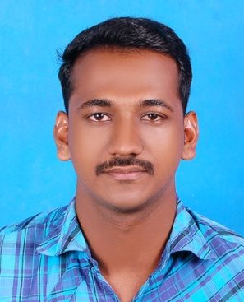

CAREER OBJECTIVE

Intend to build a career with leading corporate of hi-tech environment with committed & dedicated people, which will help me to explore myself fully and realize my potential.

EDUCATIONAL PROFILE

Course Institution Board/ Year of Aggregate
University Completion (%)

Msc . Electronics MES College MG University 2015 Awaiting
Erumely results

Bsc. Physics St.stephens college Kerala University 2013 54%
Pathanapuram

Plus- Two St.stephens hss State Board, Kerala March-2010 64%
Pathanapuram

SSLC Govt.hss State Board, Kerala March -2008 72% Pattazhy

. DATA ENTRY – SONY SERVICE CENTRE- 6MONTHS
. CURRENTLY WORKING IN HITECH DIAGANOSTIC CENTRE IN A POST RECEPTION WITH ADMINISTRATION WITH 1YR

TECHNICAL SKILLS

- MS Word 2003, 2007
- C++ Programming
- VHDL Programming
- Ms Excel

ACADEMIC PROJECT

- Thickness of insulation of different electrical wires using laser beam
- Queueless pharmacy

ACTIVITIES

Strengths

- Positive Attitude
- Understand and grasp things quickly and efficiently
- Ability to co-operative with the team and interact with all situations
- Optimistic and hard working

Hobbies

Hearing music, Traveling, Reading Books, Sports.

CONFIDENTIAL INFO

- Nationality Indian
- Date of Birth 16-02-1992
- Language Known English, Malayalam, Hindi, Tamil
- Marital Status Single
- Gender Male
- Father Reji S
- Mother Moly reji

DECLARATION

I hereby declare that the above mentioned particulars are true to the best of my knowledge and belief.

ADARSH REJI SAM

Date:
Place:Pattazhy

