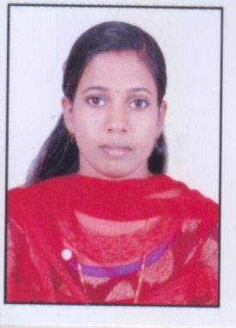
RESUME
SRUTHI M.D
E mail : sruthiunni143@gmail.com
Mob : 7025478835

OBJECTIVE
To Pursue a career in Nursing where I can use my skills and knowledge in the nursing department and extent a helping hand to this noble professional. I seek to perform my duties with total sincerity, honesty, integrity and selflessness.
OVERVIEW
- One year professional experience in Surgical ICU.
- Currently attending OET coaching
- Holding Kerala Nursing and Midwife Council Registration.
- Excellent patient management skills and ability to increase patient satisfaction.
- Extensive experience Nursing and managing administrative procedures.
- Able to take remedial action while arise a problem.
- Strong inter personal, listening and communication skills.
PERSONAL DETAILS
Name : SRUTHI M.D
Basic Qualification : GNM (General Nursing and Midwifery)
Age : 25 Yrs
Date of birth : 10-10-1992
Sex : Female
Marital Status : Married
Husband’s Name : Unni A.S
Religion : Hindu
Caste : Ezhava
Nationality : Indian
Permanent Address : Ammathusseril,
Pattanakkad P.O,
Cherthala
Alappuzha – 688 531
Languages Known : English, Malayalam & Hindi
Contact No. : 7025478835
9947263407
E mail ID : sruthiunni143@gmail.com

ACADEMIC QUALIFICATION
COURSE | INSTITUTION | BOARD OF EXAMINATION | YEAR OF PASSING
SSLC | GHSS, Thanneermukkom, Cherthala | Kerala Board of Public Examination | 2008
Plus Two | Vayalar Ramavarma GHSS | Kerala Board of Higher Secondary Examination | 2010

PROFFESSIONAL QUALIFICATION
COURSE | INSTITUTION | YEAR | BOARD/COUNCIL
G.N.M | SNMM School of Nursing, Cherthala | 2014 | Kerala Nurses and Midwives Council

WORK EXPEREINCE
Worked for 12 months in Marian Medical Centre Hospital, Arunapuram, Pala, 300 beded hospital as Staff Nurse in Surgical ICU (From 25-05-2015 to 01-06-2016).
EQUIPMENTS HANDLED
- Cardiac monitors
- Pulse oxymeter
- Incubator
- Nebulizer
- Syringe pump
- Infusion pump
- Glucometer
- ECG machine
- Suction apparatus

JOB RESPONSIBILITIES
- Provide Individual Nursing Care for each patient according to the needs.
- Admitting patients.
- Initiate the Nursing care process on all patients upon admission by recognizing changes in patient’s conditions and taking action as appropriate and recording the action.
- Orienting patients to their physical environment upon admission and there after necessary.
- Administer medication as ordered.
- Supporting patients and family emotionally.
- Reporting any unusual incident occurrence.
- Observing infection control policies.
PASSPORT DETAILS
Passport Number : S 2924992
Date of issue : 11/06/2018
Date of Expiry : 10/06/2028
Place of Issue : Cochin
DECLARATION
I hereby declare that the information given in this resume is true and correct to the best of my knowledge and belief.

Place : Pattanakkad
Date : SRUTHI M.D

