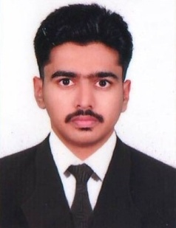
RESUME
ANEES.S
Contact Number :+919645361115,9061398835
Email :aneesskt@gmail.com
Post applied for : C.S.S.D Technician
Objective
To Purse a challenging career that exploits my ability to the maximum, while providing sufficient exposure responsibilities and opportunity to learn in an environment, which promotes innovation
& Professionalism.
Professional Qualification
Two year Diploma in Hospital Sterilization Technology (01/06/2011 to 01/06/2013) MES Medical college Perinthalmanna, Malappuram, Kerala
Educational Background
SSLC : Seethi haji memorial govt higher secondary school ,Edavanna,Malappuram
Experience
1) Worked in Ahalia Hospital Palakkad from 23.02.2015 to 22.02.2017
2) Worked in KIMS Al-Shifa Super Speciality Hospital at Perinthalmanna, Malappuram as
CSSD Technician since from 11.11.2013 to 20.02.2015
AREAS WORKED
- A . Decontamination and Disinfection
- B . Preparation and packaging
- C . Labeling
- D . Sterilization
- E . Monitoring the process and Documentation(JCI)
- F . Storage and distribution
Equipments worked on
- Modis sterilizers
- Machine fabrik sterilizer
- Medipharm sterilizer
- Trisco surgical sterilizer
- Pk surgical sterilizer
- Sturdy flash sterilizer
- Medisafe (ultrasonic cleaner)
- Steri vac (gas sterilizer 3m)
- Pci (gas sterilizer. Pci)
- Getting steam sterilizer
- Getting washing disinfector
- Getting dry machine
- Getting flash steam sterilizer
- Getting ultrasonic cleaner
- Net steel equipments steam sterilizer
- Ne steel equipment ultrasonic cleaner
- Medicare equipment steam sterilizer
- Hanshin medical steam sterilizer
Personal profile
Address : Srankitakath house , Edavanna post, Edavanna
676541 pin Malappuram Dt, Kerala .India
Date of Birth : 23.05.1992
Gender : Male
Marital Status : Single
Father Name : Abdul Majeed
Nationality : Indian
Languages : Malayalam, English
Relegion : Muslim

Declaration
I hereby declare that the above information is best and true to my knowledge
Place :Edavanna
Date : ANEES.S

