RESUME

MANIKANDAN K.R 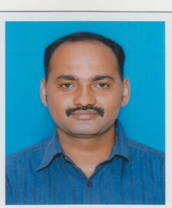
KALLUPARAMBIL (H)
POOKKALAM LANE, UDAYAMPEROOR
THRIPUNITHURA
Mobile: 7403093777, 9745234287
0484-2256578
Email ID:manikandannair77@gmail.com

Career Objectives
To gain employment with a company that offers me a consistently positive atmosphere to learn and implement new technologies for the betterment of the organization.
Academic Qualifications

Course | Institution | University/Board
SSLC | S.N.D.P HIGHER SECONDARY SCHOOL,UDAYAMPEROOR | KERALA STATE
Music And Mimicry | KALABAVAN ERANAKULAM | KERALA STATE

Extra Curricular Activities &Wook Experience
NANDHA MARKETING office Assistant for the past 3 years
ALAPATT GOLD DEN PVT LTD as Office Assistant And PRO for the past 10years.

- Deals Banking Activities, Coordination of all office works, Dealings with Customers
- Ability to work in new and challenging environment.
- Ability to Take Initiative in Doing Works.
- TwoWheeler and Four wheeler license

Personal Information

Date of Birth : 01 June 1986
Gender : male
Marital Status : Married
Father’s Name : Radhakrishnan Nair
Languages Known : English, Malayalam, and Tamil.
Hobbies : Listening music, Traveling, Reading Stories
Strengths : Confidence, Patience, Hard working
Permanent address : Kalluparambil (h)
: Pookkalam lane, Udayamperoor
: Thripoonithura

Declaration
I hereby declare that the above furnished information is correct up to my knowledge.

Place: Udayamperoor Manikandan K.R
Date: / /201

