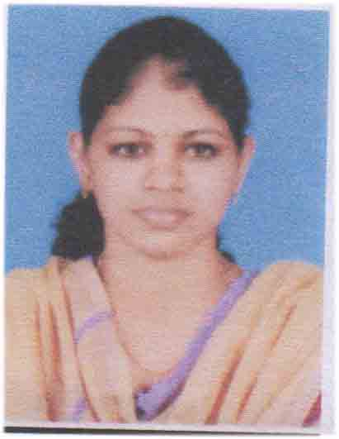
CURRICULAM VITAE
MISS. SNEHA SEBASTIAN
Nadukkudiyil House
Chungakkunnu (PO)
Kannur (Dt)
Kerala -670651
Ph:9961962118, 9526881487
Email. Snehasebastian4444@gmail.com

OBJECTIVE
Seeking a growth oriented andchallenging carrier in medical and patient care in professional reputed hospital where I can apply my knowledge and skills to the best of my abilities.
PERSONAL DETAILS
Name | : | Sneha Sebastian
Father’s Name | : | Sebastian
Date of Birth | : | 22-07-1992
Gender | : | Female
Marital Status | : | Single
Religion & Caste | : | Christian , RC
Nationality | : | Indian

LANGUAGES KNOWN
Languages | Speak | Write
English | Yes | Yes
Malayalam | Yes | Yes
Kannada | Yes | No
Tamil | Yes | No
Hindi | Yes | Yes

EDUCATIONAL QUALIFICATION
- SSLC
- PLUSTWO
- BASIC Bsc NURSING (RGUHS)
ACADEMIC DETAILS

Course | University | Name of Institution | Year | % of marks
Secondary School Leaving Certificate | Board of Public Examination | IJM Higher Secondary School | March 2008 | 74%
Higher Secondary School Leaving | Board of Public Examination | IJM Higher Secondary School | March 2010 | 77.39%

PROFESSIONAL QUALIFICATION
Course | University | Name of Institution | Year | % of marks
1st year Bsc Nursing | Rajiv Gandhi University Karnataka | Vijayanagar College og Nursing | 2011 | 69%
2nd year Bsc Nursing | Rajiv Gandhi University Karnataka | Vijayanagar College og Nursing | 2012 | 68%
3rd year Bsc Nursing | Rajiv Gandhi University Karnataka | Vijayanagar College og Nursing | 2013 | 74.3%
4th year Bsc Nursing | Rajiv Gandhi University Karnataka | Vijayanagar College og Nursing | 2014 | 75%

EXPERIENCE
- Worked as a Staff Nurse at Manipal Hospital in Bangalore from 22/10/2015 to 09/12/2017(Medical Surgical Ward)
PASSPORT DETAILS
PASSPORT NO : L6728411
DATE OF ISSUE : 17/01/2014
DATE OF EXPIRY : 16/01/2024
PLACE OF ISSUE : KOZHIKODE

CLINICAL TRAINING
- Vijayanagar Global Hospital Bangalore
  - Pediatric Nursing
  - Midwifery and obstetrical Nursing
  - Medical Surgical Nursing
- Tirumala Hospital Bangalore
- Medical Surgical Nursing
- Spandana Rehabilitation, Research and Training Centre Spandhana Nursing Home Rajajinagar
  - Mental Health Nursing
DECLARATION

I hereby declare that the above given information are true to the best of my knowledge and belief and can be supported by relevant certificate and documents

Place: Chungakkunnu
Date Sneha Sebastian

