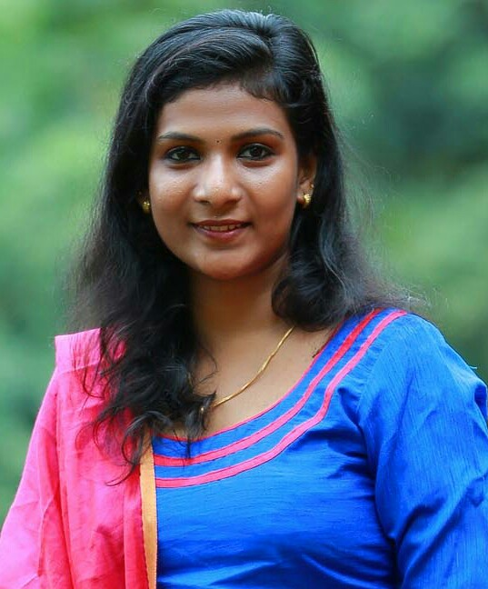
LUBY LUKOSE
NARAMANGALATHU HOUSE
KARAMALA P.O.
Poovakulam
KOTTAYAM DISTRICT
KERALA STATE
INDIA 686632 E-Mail ID : lubylukose201122@gmail.com
Mob :09702099505,08547673956

SUB: APPLICATION FOR THE POST OF STAFF NURSE

Respected sir/madam,
I Ms.Luby Lukose would like to apply for the post of Staff Nurse in your esteemed hospital.
I have completed my Bsc Nursing course from Sri.Ramachandra Collage Of Nursing, Chennai,porur in july 2015.
Given an opportunity , I would like to serve your esteemed hospital, with the best of my knowledge with fully commitment. I am also attaching my resume with this for your kind perusal.
I hope and trust that you will do the needful at the earliest, looking forward for positive response.

Thanking you,
your’s faithfully,
(LUBY LUKOSE)

OBJECTIVE:
I would like to grow as professional and would strive hard to achieve the hospital objective

.PERSONAL PROFILE
Name : Luby Lukose
Father’s Name : N.M Lukose
Sex : Female
Age & D.O.B : 23yrs, 24/08/1994
Marital status : Unmarried
Religion & Cast : ChristianR.C.S.C.
Permanent Address : Naramangalathu House,
Poovakulam.O.
Poovakulam
Kottayam district
India 686632
Nationality : Indian
Height & Weight : 155cms, 60kgs
Contact No. : +919702099505
: +918547673956
E-mail ID : lubylukose201122@gmail.com
Languages known : English, Hindi, Malayalam, Tamil
Interests : Listening to music, Reading books, Dancing

Passport details:-
Passport No. :N2606886
Date of issue :09/09/2015
Date of expiry :08/09/2025
Place of issue :Cochin

Pancard details:-
PAN : AQMPL2082M

ACADEMIC QUALIFICATIONS

Period of course | Name of course | Name of the institution | Board/University | Class
2007-2009 | S.S.L.C | S.H.G.H.S Ramapuram | Kerala Board of Public Examinations | First
2009-2011 | Plus two | O.L.L.H.S.S. Uzhavoor, Kottayam | Kerala Board of Higher Secondary education | First
2011-2015 | Bsc Nursing | Medical Trust College Of Nursing,Ernakulam | Sri.Ramachandra University in porur,chennai | First

Membership in professional council:-
Nursing Registration : Tamil nadu Nurses And Midwives Council (BscNursing Basic)
Reg. number : 159445
Registration Date : 5th August 2015

MEMBERSHIP CARD :-The Trained Nurses association of India
TANI NO :-32814/LMT

Hospitals Trained:-
- Sri.Ramachandra medical college, porur, chennai

Work experience:-
Name of the Organization | Designation | Duration | Department worked
New age Wockhardt HOSPITAL(NABH & JCI) Mumbai central,Mumbai | Staff Nurse | 5th November 2015 to 11/01/2018 | Operation Theatre (all cases including cardiac paediatric and adult)
Total experience:-2yr 2months

EMPLOYMENT HISTORY
I am worked in Wockhardt Hospitals in Mumbai central as a Staff nurse in Operation Theater
from 5/11/2015 to 11/01/2018

Wockhardt Hospitals is a 3500 bedded multispeciality hospital with Medical, Surgical, Cardiology, Urology,Neurology, Gastro Enterology, Pediatric, Laparoscopy, ENT,Ortopedic, Specialties including, 24hrs, Casuality, Operation Theatre, Well Equipped Medical, surgical, Cardiology, & paediatric Intensive Care Unit (PICU).
It is also well equipped with endoscopy, 2D ECHO, colour Doppler, 24hr whole body spiral CT scan,Cystoscopy, Laparoscopy & arthroscopy. Also it has other facilites like pathology,laboratories, radiology & 24hr blood bank

Cases attended:-
- ASD Closure
- VSD Closure
- ICR
- B.T Shunt
- Coarctation of aorta
- Bidirectional Glenn shunt
- Rastelli
- Arterial switch operation
- CABG
- MVR
- Microdisectomy
- Lumbar decompression+fixation
- Liver,Kideny transplant
- Cystoscopy
- Craniotomy
- General open cases
Equipments used:-
- Cardiac Monitor
- Defibrillator
- ECG machine
- Infusion Pump
- Laryngoscope
- Glucometer
- CUSA
- Anesthesia machine
- Diathermy machine
- Autoclaving machine
- Endoscopes
- Cardiac instruments

Specialized Nursing Skills
- CPR
- Continues monitoring
- Foley’s catheterization
- Recording and Reporting
- Blood Transfusion
- ABG
- IV cannula insertion
- Admission and Discharge
- Sterile dressing
- Assisting Intubation and Extubation
- Assisting the surgeon during surgery
- Collection of Specimen (blood,uine,etc)
- Administration of Oxygen
- Nebulisation
- Surgical Hand washing method
- Trolly draping, gowning, Etc

POCEDURES ASSITED
- All cardiac paediatric surgerys(ASD,VSD,ICR,GLENN,ARTIRIAL SWITCH,ETC)
- CARDIAC ADULT SURGERY (CABG,MVR)
- SPINE SURGERYS(Lumbar decompression+fixation,microdisectomy)
- GENERAL SURGERYS(all open cases including liver, kidney transplant)
- All Minor surgery's

COMPUTER SKILLS:-
Familiar with fundamentals of computer, MS Office, Internet and E-mail

CONFERENCE ATTENDED

- Basic Life Support
- Infection Control Program
- Fire and Safety Program
- Hand Washing Procedure

PHILOSOPHY TOWARDS SERVICE AND LIFE

I consider myself as an extravert. My patient is the best teacher have ever had off the job invest a good amount of time in educating myself through books. A hard working and professional oriented nurse believes strongly in medical ethics and practicing it as divine job.

REFERENCES :-
- Mrs.Clera Meneze
Incharge ( OT)
Wockhardt Hospitals
Mumbai central
Mumbai
Ph. Number : 9029104148

> Mrs.Presanna baby
Principal in
Sri.Ramachandra college of Nursing
Porur,Chennai
pH no : 044-45928785

DECLARATION
I here by declare that the above furnished details are true to the best of my
Knowledge and belief.

Place :-KOTTAYAM Yours Truly
Date :-11/06/2018 LUBY LUKOSE

