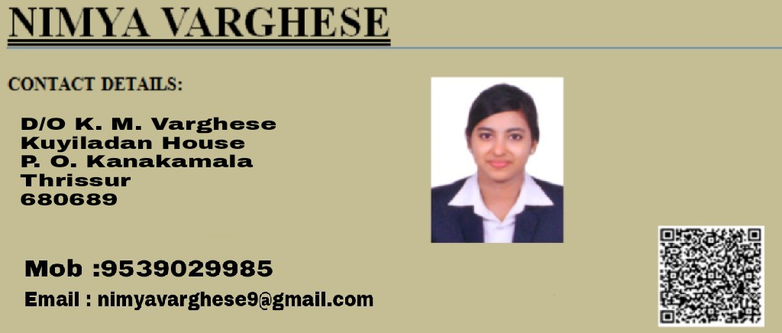
Career objective

- To work with maximum potential in a challenging and dynamic environment, with an opportunity of working with diverse group of people and enhancing my professional skills with learning and experience for career growth.
- Looking forward for higher responsibilities.
Core competency

- Ability to adapt to situations
- Decision Making
- Willingness to learn
- Multitasking
Educational Qualification

Course | College | University | Year of passing
MBA  Main : HR  Sub : System | Elijah institute of management studies | Calicut university | 2017
B.Tech | Holy Grace Academy of Engineering | Calicut university | 2015
Higher Secondary School | RMHSS Aloor | Kerala state higher secondary board | 2011
SSLC | SHCGHSS Chalakudy | Kerala State Board | 2009
````````
Professional Experience

I am working as an HR Executive in Human Resource Department at Holy Cross Group of Institutions, Kottiyam, Kollam.

Technical Skill

- MS WINDOWS XP - EXCEL,POWERPOINT,WORD,PHOTOSHOP
- GOOD TYPING SPEED
- BASICS OF ARDUINO, VHDL, ASSEMBLY LANGUAGE(8085,8086,8051)AND C.
- CIRCUIT STIMULATION SOFTWARE : MATLAB SOFTWARE,PSPICE
- OPERATING SYSTEMS :LINUX(UBUNTU),WINDOWS XP/7
Linguistic skills

- ENGLISH
- TAMIL
- HINDI
- MALAYALAM
Awards and Achievements

- Published an international journal entitled “WSN-Based Smart Sensors and Actuator for Power Management in Intelligent Buildings”in INTERNATIONAL JOURNAL OF ADVANCED RESEARCH TRENDS IN ENGINEERING AND TECHNOLOGY (IJARTET)
- Best project award in college and state level.
Projects and Seminar

MBA
MAIN PROJECT: IMPACT OF REWARD AND RECOGNITION ON EMPLOYEE MOTIVATION
Successfully Completed the Project and Internship program(45Days)titled IMPACT OF REWARD AND RECOGNITION ON EMPLOYEE MOTIVATION with special reference to CARRIS PIPES AND TUBES PVT. LTD.KOOVAPPADY, ERNAKULAM

MINI PROJECT: EFFECTIVENESS OF PAYROLL MANAGEMENT SYSTEM
Successfully Completed the Project and Internship program(20Days)titled EFFECTIVENESS OF PAYROLL MANAGEMENT SYSTEM with special guidance to PASSIONLABS, Kochin.

B.TECH
- INTERNATIONAL JOURNAL PUBLICATION

Published a Research Paper entitled “WSN-Based Smart Sensors and Actuator for Power Management in Intelligent Buildings”in INTERNATIONALJOURNAL OF ADVANCED RESEARCH TRENDS IN ENGINEERING AND TECHNOLOGY(IJARTET)
- MAIN PROJECT : GESTURE VOCALIZER
- MINI PROJECT :DTMF BASED HOME AUTOMATION

Certification

- Successfully Completed the Project and Internship program titled IMPACT OF REWARD AND RECOGNITION ON EMPLOYEE MOTIVATION with special guidance to AQUA TECH, Kochin.(45 Days)
- Successfully Completed the Project and Internship program titled EFFECTIVENESS OF PAYROLL MANAGEMENT SYSTEM with special guidance to PASSIONLABS, Kochin.(20 Days)
- Has successfully under gone a course of EMPOWER orientation programme with Best performer title. (5 Days)
- Participated in a short term sandwich course on ‘Marine Electronic Equipments’ conducted by Central Institute of Fisheries Nautical and Engineering Training (CIFNET), Kochi. (5 Days)
- Participated in workshop ‘Double Click IT’ organized by I ndian Institute of Information Technology and Management (IIITM), Trivandrum.(1 day)
- Participated in SEOTECH Workshop based on Social Networking, SEO & SEM by MSSPL, IIT Kanpur.(2 Days)
Industrial Training

- Company:Aquatech,Ernakalam Duration:45Days
- Company:Passionlabs,Kochi Duration:20 Days
- Company:Keltron,Kannur Duration:7 Days
- Company: Cifnet, Kochi (A Unit under Central Gov.) Duration:5 Days
- Company: Rhydo Technology , Kochi Duration: 3 Days
- Company: MSSPL-IIT, Kanpur Duration:2 Day
- IITM-K, Technopark Campus, Thiruvanathapuram Duration:1 Day
- Company: Orion Technology, Thrissur Duration:2 Days
- Company:Keltron, Ernakulam Duration:1 Day

VOLUNTEER

- President of HR club of college at 2015-2016 academic year.
- President of Electronics and Communication Association of college at 2012-2013 academic years.
- Class representative and association heads at college.
- Coordinator in job fair at ELIMS 2016.
- Best Manager coordinator in management meet EMINENCE 2K16
Extracurricular Activities

- Won in Malayalam extempore at state levels.
- Participated and won in Malayalam and English extempore speeches, presentations and debates at school and college.
- Has successfully under gone a course of EMPOWER orientation programme with Best performer title.
- Participated and won in Drama with Best actress title at state levels.
Strength

- Good communication skills
- Confidence.
- Ability to work with a group and leadership quality
- Physically fit with a caring and responsible attitude.
Reference

- Mrs Jyothis Rachel
Associate professor ELIMS Thrissur
Ph:9446286624
- Mrs Anila M. S.
Associate professor ELIMS Thrissur
Ph:9526263458
Personal profile

NAME : Nimya Varghese
GENDER : Female
DATE OF BIRTH : 02/06/1993
MARITAL STATUS : Single
MOBILE NO : 9539029985
EMAIL : nimyavarghese9@gmail.com
DECLARATION
I hereby declared the above furnished details are true and the best of my knowledge.
Yours truly,
NIMYA VARGHESE

