CURRICULUM VITAE

BLESSY MOL THOMAS
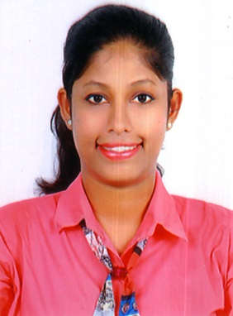

E-Mail: blessy0028@gmail.com
Mobile: 9526056399, 9447176265

ADDRESS
Hindalco South Block Quarters Kuttikkattukara,
Udyogamandal P.O., Eloor,
Ernakulam Dist., Pin- 683 501
Kerala State, India

PERSONAL PROFILE
Name : Blessy Mol Thomas
Father’s Name : Thomas B.P
Date of Birth : 28.02.1995
Sex : Female
Marital Status : Single
Religion, Caste : Christian, Orthodox
Nationality : Indian
Languages Known : English, Malayalam
Passport No : R4123499
ACADEMIC QUALIFICATION
- B.A. English Language & Literature
- Studying Diploma in Aviation Management at CIAL ACADEMY Cochin.
- Currently working as a trainee in AIRINDIA at COCHIN INTER NATIONAL AIRPORT
CAREER OBJECTIVE
To undertake responsibilities to work in a competitive environment so as to contribute the best of my ability towards the welfare of the organization and also to grow as person and become a successful professional.
KEY COMPETENCY
- Truthfulness
- Passion
- Obedient
- Politeness
- Creative
- Good Communication
- Good Decision-making
- Good critical thinking
DECLARATION
I hereby declare that all the particulars furnished above are true to the best of my knowledge.

Place: Eloor
Date: Blessy Mol Thomas

