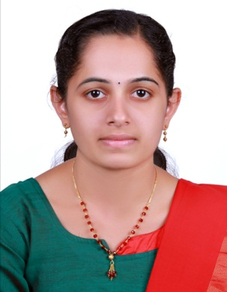
NEETHU RAVEENDRAN
MAMPRAYIL (H)
VALLICHIRA (PO)
ARUNAPURAM ,
KOTTAYAM, 686574
KERALA
MOB : +918606691535
Email:neethuraveendran65@gmail.com

OBJECTIVE

To obtain a position that would be sensitive to the needs of an experienced nurse. I would like to get an employer who is willing to utilize my knowledge and experience as well as my academic accomplishment

ACADEMICS

COURSE | BOARD/UNIVERSITY | INSTITUTION | YEAR OF PASSING | MARKS OBTAINED IN PERCENTAGE
GNM Nursing | Osmania University Hydrabad | Mythri School of nursing | 2011
 |  |  | 1st year | 68%
 |  |  | 2nd year | 70%
 |  |  | 3rd year | 72.6
 |  |  | Internship | 82.33%
PLUS TWO | Kerala Higher Secondary Board | N.S.S H.S.S Kidangoor | 2007 | 64%
SSLC | Kerala Higher Secondary Board | S.V N.S.S HS Edanad | 2005 | 67%

EXPERIENCE DETAILS
Period | Institution | Designation | Nature of work
24/09/2012 to  25/10/2013 | Ananthpuri Hospitals, Thiruvanandapuram | Staff Nurse | Accident And Emergency
04/11/2013 to 21/01/2016 | St. Jude Hospital, Ayarkunnam | Staff Nurse | Accident And Emergency
02/11/2016  To 04/02/2018 | Ananthpuri Hospitals, Thiruvanandapuram | Staff Nurse | Observation Department

PERSONAL PROFILE

Name | Neethu Raveendran
Date of birth | 20/03/1989
Languages | English, Malayalam
Gender | Female
Marital Status | Married
Nationality | Indian
Place of Birth | Pala
Permanent Address | Neethu Raveendran  Mamprayil (H)  Vallichira (PO)  Arunapuram ,  Kottayam, 686574  Kerala
Passport Details | M1879655

REFERENCE
Mrs, Prema John
Nursing superintendent
Ananthapuri Hospitals And Research Institute
Thiruvananthapuram, 895024
Ph: +914712606565

DECLARATION
I Neethu Raveendran hereby declare that the above details are true and correct the best of my knowledge and belief.

Place :Vallichira NEETHU RAVEENDRAN
Date:

