Dr. Farzeen Av (MBBS)
Mob :- +919496741616
+918770522615
E-mail :- farzeenalifan@gmail.com
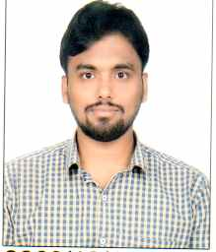
EDUCATION:-
Bachelor Of Medicine And Bachelor Of Surgery (MBBS)
Institute :- Shyam Shah Medical College , Rewa , (M.P).
University :- Awadesh Pratab Singh University , Rewa .
One year Rotatory internship as a resident intern completed .

