RESUME
Bibin. c  KARAKKAL House  ULLANAM P O,  PARAPPANANGADI  Malappuram, Kerala – PIN 676303  Ph: 9633381598  Email: bibinnandhanam@gmail.com | 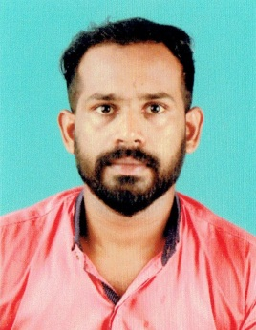

Objective
To work in your organization where I can contribute to its growth with my dedication and hard work. From my academic experience I am very confident to do all sort of duties that are necessary for the company.
Strength
- Desire to work hard and excel
- Team work
- Good communication skills
- Positive attitude
Educational Qualifications
Course | Institution / University | Year | Percentage
BCA | Bharathiar University, Coimbatore | 2015 | 65%
Electrical Engineering | KGCE | 2012 | -
Plus Two | Board of Higher Secondary Examinations | 2009 | 60%
10th | Board of Public Examinations | 2007 | -
WORk EXPERIENCE
- 3 years as Electrician at Nahas Hospital, Parappanangadi
Personal Details
Date of Birth : 04-06-1991
Gender : Male
Nationality : Indian
Languages Known : Malayalam & English
Marital Status : Single
Declaration
I hereby declare that the above mentioned information is correct up to my knowledge and I bear the responsibility for the correctness of the above mentioned.
BIBIN.C

