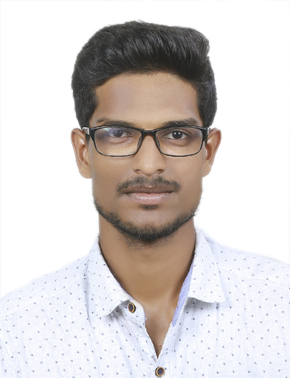
CURRICULUM VITAE

SAJIN . S
PLAPPALLIYIL HOUSE
PAKKIL P.O
KOTTAYAM - 686012
MOB - +918304023281
EMAIL- sajin.96052@gmail.com

OBJECTIVES  PERSONAL INFORMATION  QUALIFICATIONS SUMMARY  EXPERIENCE | TO MAKE OPTIMUM UTILIZATION MY KNOWLEDGE AND SKILLS, UTILIZE OPPORTUNITIES EFFECTIVELY FOR PROFESSIONAL GROWTH AND TO CONTRIBUTE IN THE BEST POSSIBLE WAY FOR THE BETTERMENT OF THE ORGANIZATION AND SELF.  - FATHER’S NAME :- SASIKUMAR M N  - MOTHER’S NAME : - ANITHA SASIKUMAR  - DATE OF BIRTH :- 20/11/1993  - GENDER :- MALE  - RELIGION & CASTE :- HINDU ,VISWAKARMA  - NATIONALITY :- INDIAN  - MARITAL STATUS :- SINGLE  - S.S.L.C, FORM CHINMAYA VINJAN MANDIR HIGH SCHOOL, MOOLAVATTOM, KOTTAYAM , KERALA PASSED ON MARCH 2009 WITH 70% AGGREGATE  - HIGHER SECONDARY FORM GOVT MODEL H.S.S KOTTAYAM, KERALA PASSED ON MARCH 2011 WITH 61% AGGREGATE  - BSC NURSING FROM I . N. E , C.P.A.S , ANDOOR, PALA ,KOTTAYAM , KERALA WITH 64% AGGREGATE  - Nil

