CURRICULUM VITAE

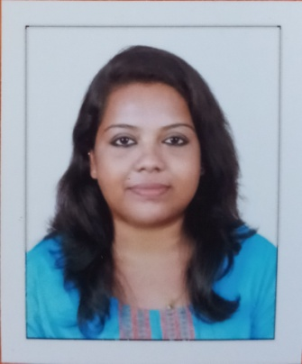
ANU MOHAN
VANCHIPURAKKAL (H)
ERAMALOOR .P.O.,
CHERTHALA,
ALLAPEY (DIST)
KERALA 688537
Mob:No: +91 8129536761
E-mail:mohanan.anu0101@gmail.com.

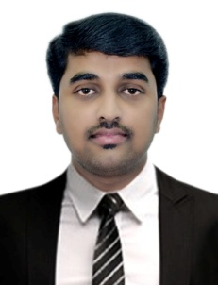

CAREER OBJECTIVE

To live honest and hard life to work in a highly challenging competitive environment for the enhancement of my creative abilities and optimum profitability of the organization and I am confident that I can serve your reputed organization by giving significant contributions and relevant advances from my career.

EDUCATIONAL QUALIFICATIONS

2014 - 2016 KUHS University
Master of Hospital Administration(MHA) (Regular) Little Flower Institute Of Medical Science and Research, Ernakulam

2009 – 2014 Dr. NTR University, Andhra pradhesh
B.Sc Nursing from Narayana Nursing College, Nellore

2007 – 2009 Central Board Of Secondary Education , Kerala
12th from Kendriya Vidyalaya Ernakulam

2006- 2007 Central Board Of Secondary Education , Kerala
10th from Kendriya Vidyalaya Ernakulam

STRENGTH

- Positive attitude
- Confident
- Good team management skills.
- Hard working, Punctual and ambitious

PERSONAL PROFILE

Gender : Female
Date of Birth : 06/08/1991
Marital Status : Single
Nationality : Indian
Religion : Hindu
Hobbies :,Listening music,cooking
Languages : English, Hindi, Malayalam, Tamil

EXPERIENCE

Worked as Admin Executive in Moham Hospital, Eramalloor, Allapey

PROJECTS UNDERTAKEN

MHA
- Major Project: A Study On Service Quality Dimensions which affects the patient satisfaction in Lakshmi Hospital Ernakulam
- Minor Project:A study To Assess The Knowledge and Practice Regarding Triage System Among Staff Nurse In Emergency Department Of Daya General Hospital, Thrissure

CONFERENCES ATTENDED
- National conference on Health Care Management “Frugal Innovation In Health Care” CONCETTO 2016 organized by Department of Hospital Administration, Amrita Institute of Medical Science and Research Centre, Kochi on 20th and 21st May 2016.

REFERENCES

- Fr Dr.George M D, Principal of Little Flower Institute Of Medical science and Research, Angamaly

DECLARATION

I hereby declare that the above stated are true and correct to the best of my knowledge and belief.

ANU MOHAN
Date:
Place: Eramalloor

