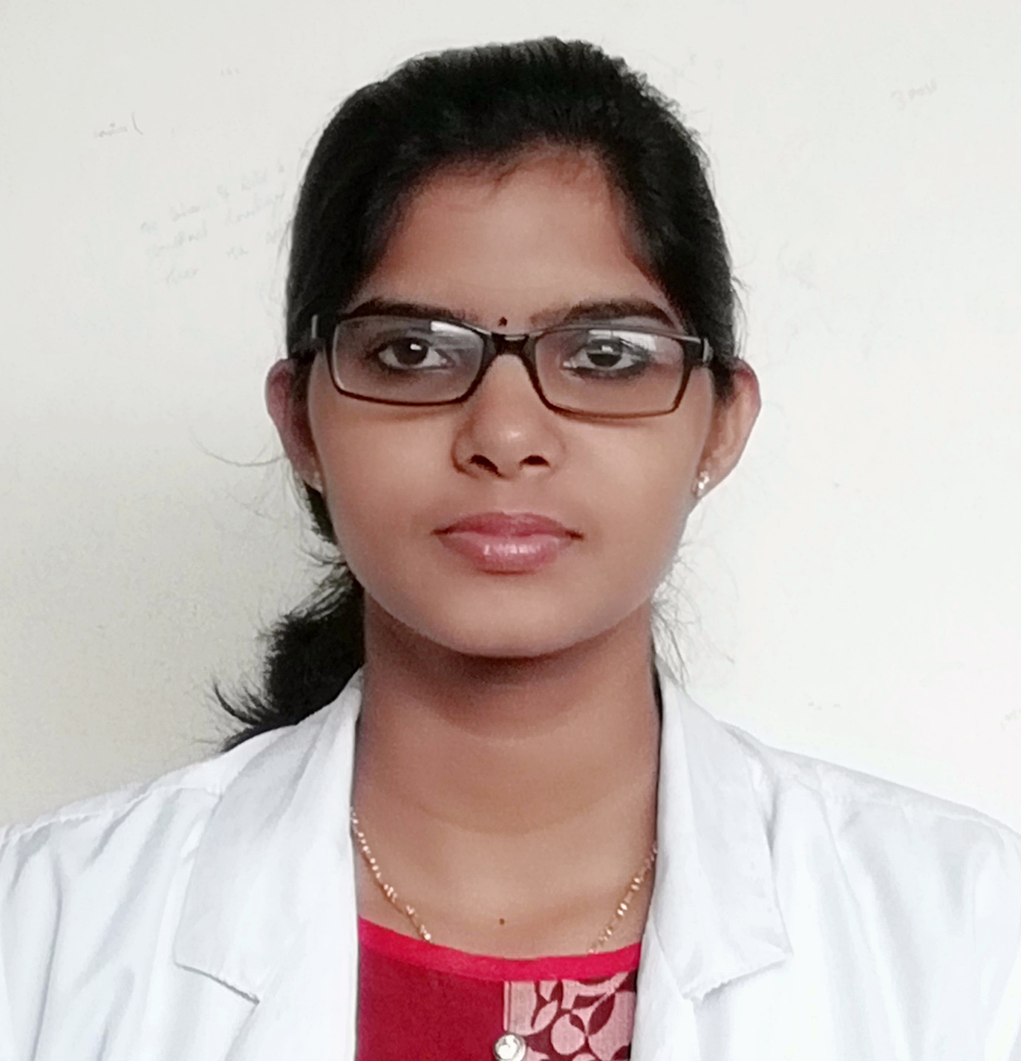  CHRISTEENA  NOBLE  :christeenanoble@gmail.com  : +91-8123982550  ADDRESS FOR COMMUNICATION:  Kizhakkayil House  Kudiyanmala P.O,  Naduvil via  Kannur, Kerala  PIN 670-582  PERSONAL PROFILE:  Date of Birth:  03th October 1995  LANGUAGES KNOWN:  English, Malayalam,kannada  PROFESSIONAL SKILLS  - Ability communicate well  - Ability to accept challenges and apply proper treatment method.  - Good speaker and listener.  - Leadership skills.  - Ability to deal with the people.  - Good Team Player  - Optimistic  - Interpersonal skill | CURRICULAM VITAE  CAREER OBJECTIVE  To have a growth oriented and challenging career, where I can contribute my knowledge and skills to the organization and enhance my experience through continuous learning  EDUCATIONAL QUALIFICATIONS:  Exam/degree Year Name of institution University/ Board Percentage  BPT 2018 Yenepoya university Mangalore Yenepoya university 1st year-66% 2nd year-63% 3rd year-68% 4th year-69%  Plus two 2013 G.V.H.S.S Kannur State Board of Kerala 78%  SSLC 2011 Cherupushpa H S Chandankampara State Board of Kerala 88%  PROJECT,POSTINGS  - Project on “awareness and knowledge of antenatal exercises among pregnant women who are attending antenatal care in Yenepoya Medical College Hospital.”  - Rural posting-Harekala primary Health Centre  - Urban posting-Vamanjoor Palliative Care Centre,Olavanahalli old age home,Kavankatte special school  ACHIEVMENTS  - Certified dry needling therapist  - Completed certificate course in MANUAL Therapy (CMT) in the integrated approach for the vertebral column, pelvic complex,TMJ joint, neural tissue and extremities  - Completed Spinal manual therapy by IOMT  - Attended workshop on “physiotherapy in Wound healing”  - Participated in International physiotherapy conference  - Attended workshop on role of national and international organization in the community based rehabilitation and disaster management  - Attended the workshop on “understanding autism, its cause, diagnostic criteria, and assessment”  - Participated 4 times in South India inter- university championships for basketball  - As a team physio of Yenepoya Basketball team.
TECHNICAL SKILLS  - MS Office  - Basics of computer  HOBBIES:  - Gardening  - listening music  - Engaging in different sports and games.  - reading  - Experiments on cooking | PERSONAL DETAILS  Name :CHRISTEENA NOBLE  Gender :Female  Nationality : Indian  Marital Status : Single  Name of Father :NOBLE K C  Name of Mother :ELSAMMA NOBLE  Intrests :Getting to know new people  : Social medias communication.  : Meditation  :Adventure sports.  : Personal objective  :To be a good human being always  DECLARATION  I hereby declare that the above information furnished by me is true to the best of my knowledge and belief.  Date: 19-04-2018  Place: CHRISTEENA NOBLE

