SANDRA K.M
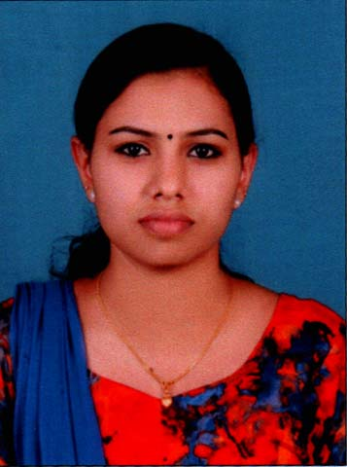
Kandathinkara House
Chilavu P.O
Olickamattom
Thodupuzha, Idukki District
Kerala , PIN 685588
Ph No 9746287755, 7025644576

OBJECTIVE
To serve as an energetic, inspiring staff nurse where the spirit team work is encouraged so I can grow as a person, as an employee and as a professional.

PERSONAL DETAILS
Name : SANDRA K.M
Date of Birth : 28.04.1994
Gender : Female
Nationality : Indian
Email : sandramohanan284@gmail.com
Marital Status : Single
Religion : Hindu
Languages known : Malayalam ,English ,Hindi
EDUCATIONAL QUALIFICATIONS
Qualification | Board/University | Year Of passing | Name of Institution | Remarks
General Nursing and Midwifery (GNM) | Kerala Nurses and Midwives Council | 2015 | Govt. School of Nursing Idukki,Muttom | 79%
Plus Two | Board of Higher Secondary Examination Kerala | 2011 | St. Joseph's Higher Secondary School Karimannoor | 84%
SSLC | Board of Public Examination Kerala | 2009 | St. Joseph's Higher Secondary School Karimannoor | 80%

CURRENT REGISTRATION STATUS
Certificates | Nursing Council | Certificate Register No.
Certificate of Registration General Nursing & Midwifery | Kerala Nurses and Midwives Council | KL01201500176
Diploma Certificate | Kerala Nurses and Midwives Council
EXPERIENCE SUMMARY
Name of the Hospital | Period of employment | Job Title | Area
District Hospital, Thodupuzha | 14.01.2016 to 14.01.2018 | Registered Nurse | Casualty, Medical & Surgical Ward
PHC Kallar, Vattiyar | 26.08.2015 to 10.01.2016 | Registered Nurse | OP Department

CASES HANDLED
- Cardiac arrest, Arrhythmia, LVF, MI, SHOCK, Aortic rupture, Thoracic trauma, PE, DVT, AGE, Poisioning, Meningitis, Convultions, DM, DKA, hypo/hyperglycemia, hematological disorders, acid base disturbances, electrolyte imbalances, ,respiratory failure, respiratory arrest, ARDS,COPD, pneumo/heamothorax, chest injuries, bronchialasthma, pneumonia, ARF, CRF, Renalcolic, anaphylaxis, drowning, burns, airway obstruction, geriatric/gyenacholagial emergencies etc.
SUMMARY OF SPECIALIST SKILLS
- Competent in assessment and management of cardiac emergencies.
- Knowledge about ECG, cardiac drugs and equipments
- Experience in liaising with medical and other staff.
- Efficient use of and maintenance of ICU equipments critically ill and cardiac patients.
- Ability to respond rapidly and appropriately to crisis incidents, such as emergency airway obstruction, bleeding or cardiac arrest.

CONTINUING EDUCATION
In-service educational sessions include:
- International trauma life support provider
- Advancement in critical nursing
- Invasive ventilation workshop for nurses.
- Emergency care nursing workshop
- Infection control
- Equipment demonstrations e.g. cardiac monitors, infusion pumps, syringe pumps, defibrillator, ventilator.
PROCEDURES ASSISTED
- Pleural tapping
- Bladder wash
- Abdominal tapping
- Defibrillation
- ICD insertion
- Intubation
- Tracheostomy
- Bowel wash
- Lumbar Puncture
- Broncoscopy
INVASIVE AND NON INVASIVE PROCEDURES
- Foley’s Catheter Insertion
- Vitals monitoring
- ECG
- Colostomy Care
- Ryles tube insertion
- Suctioning
- Surgical dressing
- Blood Tests
EQUIPMENTS HANDLED
- Cardiac monitors (Multi para)
- AED
- Defebrilators
- Ventilators
- Ambu Bag
- Airway adjunctants
- Suction machine
- Tracheostomy set
- Infusion/Syringe pumps
- Trauma Kit
MANAGEMENT OF PATIENT CARE
- Admission and orientation of the patient
- Assessment of the patient needs and planning for patient care
- Support the activities of daily living
- Assessment of emergencies
- Maintenance of records and reports
- Patient teaching
- Appraisal of nursing service
PERSONAL STRENGTHS
- Calm and enduring
- Flexible and resourceful
- Takes initiative and is inquisitive
- Enthusiastic to learn and hard working
- Loyal and punctuality

REFERENCE
Dr. Uma Devi
Superintendent
District Hospital, Thodupuzha

Mrs .V.N.Indira
Nursing Superintedent
District Hospital, Thodupuzha
Ph no :9447212025
DECLARATION
I hereby declare that the above mentioned details are true to the best of my knowledge and ability

Place :Chilavu
Date : 01/05/2018 SANDRA K M

