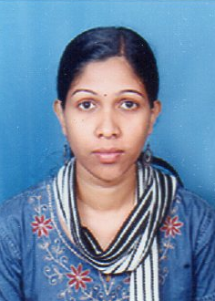
Ms.Anumol Sadanandan
Ph : +91 9650306277
+919446892324
Email: anumol.bj@gmail.com

Objectives:
Seeking a growth – oriented and challenging carrier in Nursing and patient care in professional reputed hospital where I can apply my knowledge and skills to the best of my abilities.
Personal details
Date of birth: 13/05/1991
Place of birth: Bharananganam
Father’s Name: Sadanandan
Husband Name: Beji George
Permanent Address: Velathuparambil(H),Arpana road
Palluruthy p.o, Ernakulam, kochi-6

Religion: Christian
Gender: Female
Nationality: Indian.
Marital status: married.
Language known: English, Malayalam, Hindi

PASSPORT DETAILS:
Passport no. K7229284 | Date of Issue  09-01-2013
Place of Issue  cochin | Date of Expiry  08-01-2023

EDUCATIONAL QUALIFICATION
Course | Institution | Years of Passing
SSLC | Alphonsa Girls H S Vakakkadu,Moonilavu | 2006 march
HSS | Govt. Higher Secondary school Erattupetta | 2008 march

PROFESSIONAL QUALIFICATION:
Course | Institution | Years of passing
B.Sc Nursing | TadikelaSubbaiahCollege of Nursing  Shimoga, Karnataka | 2012 august

EMPLOYMENT HISTORY
Name of Institution | Post held | Duration | Area
- Apollo Hospital Greams Road Chennai  - Fortis Hospital.  Noida | Staff Nurse  Staff Nurse | 14/08/2013  To  05/01/2016  03/11/2016 To 15/01/2018 | Renal ICU/  Cardiactransplant ICU  Liver transplant ICU

SPECIAL TRAINING
CourseInstitution
Basic Life Support Apollo Hospitals, Chennai
Advanced Cardiac Life Support Apollo Hospitals, Chennai
Basic Trauma Life Support Apollo Hospitals, Chennai

Computer knowledge
Basic knowledge in computer.

JOB RESPONSIBILITIES
- Basic nursing care of patient with in the standards of nursing practices.
- Initial assessment and triage of patient and inform the physician
- Checking vital signs blood glucose analysis, taking ECG , urine analysis .
- Maintaining intravenous fluids and ionotropicsupports .
- Assist the physician in diagnostic and therapeutic procedures .
- Cardiac monitoring .
- Pre and post operativecare .
- Independently perform bedside procedures like Foley’s catheter, rhyles tube and IV access.
- Maintaining records and reports.
- Performing wound dressing , ET care, suctioning.
- Pleural tapping ,gastro-bronco-colonscopy,inter costal drainage .
- Monitor and maintain CVP, BP ,ABG. These Institutions consist of the following
- General medicine
- Respiratory
- Cardiology
- Child and adolescent guidance
HANDLING EQUIPMENTS

- Cardiac monitor
- Suction apparatus
- ECG machine
- Ventilator
- Defibrillator
- Syringe pump
- Glucose meter
- Infusion pump
- BP apparatus
- 02 cylinder
- Nebulizer
- Ecmo Machine

REFRENCES:
- Dr.Nagendra MBBS ,MD FAGE
Subbaihcollege, jail road
Shimoga,
Karnataka- 577201
Ph:+918182270139
- Mrs. Girija
Nursing superintendent,
Apollo hospitals,
Greams lane, Chennai
Ph: +914433136613
- Mrs. Sunitha
Nursing Director,
Apollo hospitals,
Greams lane, Chennai
Ph: +9144 28296658
+9144 28296777

DECLARATION :
I hereby declare that the above information given by me is true to the best of my knowledge and belief. I am on possession of original and i will produce the same on demand
PLACE:Noida
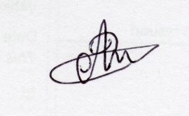
DATE:30/04/18

Anumol Sadanandan

