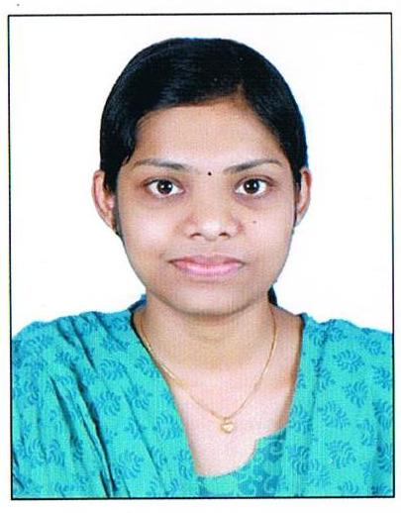
CURRICULUM VITAE
MINTU MAMACHAN
KARIYELI HOUSE
CHELAD P.O, KOTHAMANGALAM
ERNAKULAM, KERALA

APPLICATION FOR THE POST OF STAFF NURSE

Objectives: To care out nice for myself in the corporate world and obtain professional and personal satisfaction by contributing best for the organization.

Personal Details
Father’s Name :: Mamachan K M Date of Birth :: 14/03/1993
Sex :: Female
Religion :: christian
Caste :: JS
Nationality :: Indian
Contact Telephone Number :: 7034059377
Email :: mintumamachan14@gmail.com
Languages Known :: English, Malayalam, and Hindi.
Educational Qualification
Year | Name of Course | Institution | University/ Board | %
2008 | S.S.L.C. | St.Augustine’s Girls H S S  Kothamangalam | Departument of General Education. | 95
2010 | Plus Two | St.Augustine’s Girls H S S  Kothamangalam | Board of Higher Secondary  Examination | 92

Professional Qualification
Year | Name of Course | Name of Institution | Board/ University
2014 | Bsc Nursing | MOSC College of Nursing, Kolenchery | Kerala University of Health & Science

Academic Performance- Bsc nursing
Year | % of Mark | Division
1Year | 62.1 | 1st class
2Year | 64.7 | 1st class
3 Year | 67.5 | 1st class
4th Year | 69 | 1st class

(a) Duties and Responsibilities:

- Performs and assists doctors with admission transfer and discharge procedures.
- Provides priority nursing care.
- Utilized nursing processes in the care of patient and make necessary alterations as the condition of the patients.
- Documents vital sings and intake output after careful assessment.
- Carries out each activity in such a way that will enhance the speedy recovery of the patient.
- Attends to physical needs psychological, spiritual and social needs of the patients.
- Carried out doctors legal orders.
- Help doctors in the diagnosis special observation properly
- Keep up 10 rights of the patients when administering medications.
- Provides technical help in the diagnostics and the therapeutic procedures.
- Assure aseptic in all procedures.
- Prepare the patient physically and mentally.
- Documents the treatment/medications given and all special observations clearly.
- Institute appropriate measures for emergencies and critical situations.

(b) Duties towards the management of ICU:

- Supervisors and coordinate the nursing care given to the patient and all activities within the units.
- Supervises and maintains the orderliness of the ICU.
- Help the charges nurse in planning and ICU management.
- Maintains daily census book, daily round book, morning-night reports, other nursing records and reports.
(c) General:
  - Maintain good interpersonal relationship with all personnel.
  - Perform other duties as may be assigned.
  - Arrange health education to patient as per need.
  - Participated in staff meetings, education and other professional activities.

Machine / Equipments Handed:

    - Cardiac Monitors.
    - Defibrillators
    - Central Monitors
    - Pulse Oxy meter
    - Infusion Pump
    - Glucometer
    - Stethoscope / Sphygmomanometer
    - Nebulizer
    - Steam inhaler
    - Suction Machine
    - ECG machine
    - Syringe Pump
    - Laryngo Scope
    - Ambu Bag
    - Foetoscope
    - Airway
    - Dressing Set
    - Warmer
    - Incubator
    - Spiro meter
    - Nasal Probe
    - Thermometer
    - Weighing Machine (Adult & pediatric)
    - Way Adaptor / I.V Cannula
    - Tractions
COMPUTER SKILLS
Familiar with fundamentals of computer and internet
REFERENCE
- Prof. Susamma Thomas 2. Sr. Susanna
Principal Vice Principal
MOSC College of Nursing MOSC College of Nursing
Kolenchery Kolenchery
Ph: 04843055660 Ph:9447216560

DECLARATION
I hereby declare that the above furnished facts are true to the best of my knowledge and I am ready to bear the consequence if any of the above mention facts and proven to the wrong.

Place : Kothamangalam
Date : 6/1/2015.
MINTU MAMACHAN

