CURRICULAM VITAE
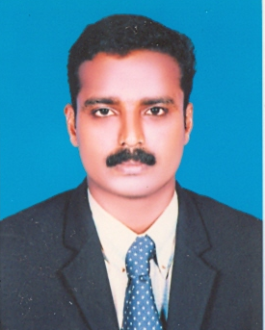

Vinayaraj.V.Pappunni
Mob : 9037675072 E-Mail: mailto.vinayaraj@rediffmail.com
: vinayarajp2@gmail.com

PERSONAL DATA

Father’s name : K.C.Pappunni
Date of Birth : 23/05/1978
Civil status : Double
Nationality : Indian
Address : Kairaly, Pattanakad.P.O. Cherthala,
Alappuzha (Dist.), kerala, India, 688531

CARREER OBJECTIVE

I would like to work for a company that is excellence given and promotes personal development based on an employee’s dedication, loyalty, and work ethic. Most importantly, being able to contribute towards the success of company.

EDUCATION

- Diploma in HOTEL MANAGEMENT from advanced management council, Kerala. (IIMS. Cochin, India.)
- BA.Lit.Eng.from Calicut university.(not completed)
- Pree Degree Certificate Commerce from Kerala University.
- Data Entry Operation from IGMF Thiruvanathapuram.

EXTRA QUALIFICATION

- Best Youth Organizer Award from Govt.of India (2004)

WORK EXPRRIENCES
#Company : Kairaly Hotels & Holidays,Alappuzha (Housekeeping Consultancy ) (01/08/2013 To at Present )
Designation : Genaral Manager
#Company : MEDICAL trust hospital, Cochin (08/08/2011 To 20/07/2013)
Designation : Ex. Housekeeper
#Company : ABAD Property Management, Cochin (01/06/2011 TO 05/08/2011)
Designation : Ex. Housekeeper
#Company : WHITE GATE RESIDENCY, Vaikom, Kerala (11/03/2010 to 03/01/2011)
Designation : Ex. Housekeeper
#Company : SHARJAH NATIONAL HOTELS (OCEANIC HOTEL), Sharjah, (21/05/2007-26/05/2009)
Designation : Room boy and resign as a senior room boy
#Company : THE AVENUE REGENT, Cochin, India (05/01/2005 to23/02/2007)
Designation : Housekeeping Supervisor
#Company : STERLLINGRESORT, Kodaikkanal, India (01/03/2002 to28/10/2004)
Designation : Housekeeping Supervisor
#Company : YUVARANI RESIDENCY, Kerala, India (10/08/1999 to 25/02/2002)
Designation : Room boy
#Company : THE AVENUE REGENT, Cochin, India, (01/06/1999 to 31/07/1999)
Designation : Industrial trainee.
REFERENCE
Mr. Abdul rahman pocker Mr.Dileep A Nair
Executive house keeper HR Manager
Oceanic hotel & resorts Medical Trust Hospital,
Khorfakkan, Sharjah. Kochi, Kerala
Phone no: 0097-1505165185 0091-9995666088
DECLARATION

I hereby declare that the above furnished details are true and correct to the best of my knowledge and belief.

Yours faithfully
Place:
Date: VINAYARAJ.V.P.

