ADITHYADEV 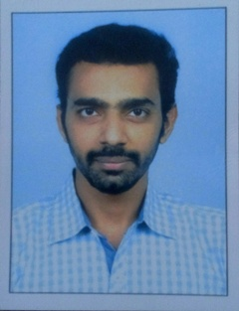
EMAIL ID : adithyadevks@gmail.com
CONTACT NO. : 8089243489

EDUCATIONAL QUALIFICATIONS:
Course | University/Board | Year | Percentage
M.Com(Banking) | MG University | 2014-2016 | Completed
B.Com (Taxation) | MG University | 2010-2013 | 57%
Plus Two | State | 2008-10 | 70.33%
SSLC | State | 2008 | 70%

- ACADEMIC PROJECT:
M.com-
TITLE-A STUDY ON CUSTOMER PERCEPTION TOWARDS MUTUAL FUNDS
Description- The major objectives of the project was to Understand the customer perception towards Mutual Fund, To know about the extent satisfaction of investors towards Mutual Fund, To evaluate the awareness of customers in Mutual Fund, To understand the customers investing power and their interest in Mutual Fund, To find out the type of scheme of mutual fund preferred by investors.
- ADDITIONAL SKILLS:
- DIFA- DIPLOMA IN INDIAN AND FOREIGN ACCOUNTING (IAB CERTIFIED)(TALLY INCLUDED)
- MS-Office
- CAREER OBJECTIVE: TO AVAIL THE OPPURTUNITIES AVAILABLE IN THE ACCOUNTING WORLD AND FACE THE CHALLENGES BY USING KNOWLEDGE.

- AREAS OF INTEREST: CRICKET, FOOTBALL, MUSIC, MOVIES

- EXPERIENCE: CURRENTLY WORKING AS ACCOUNTS OFFICER AT ROHINI AGRO SCIENCE, KOCHI (from 2016 December Onwards)

PERSONAL PROFILE
Name : ADITHYADEV
Father’s Name : SANTHOSH.K.P
Date of Birth : 25-03-1993
Sex : MALE
Address : KARUTHANATHU HOUSE,
KARUMALLOOR P.O
THATTAMPADY – 683511
Residing at : EDAPPALLY
Nationality : INDIAN

DECLARATION:
I do hereby declare that the above given statements are true and correct to the best of my knowledge.
ADITHYADEV

