RESUME
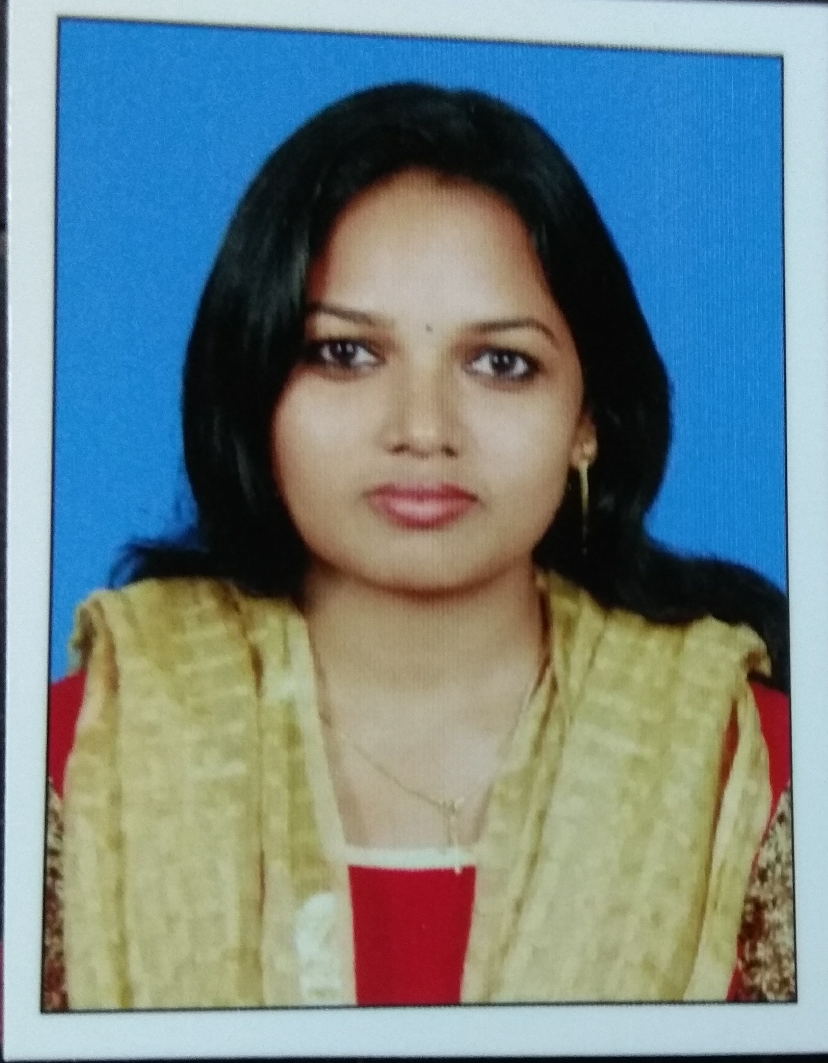
MILDA FIGAREDO
Pathissery House
Ochanthuruth P.O
Puthuvype,Vypin
Ernakulam, India.
Mobile: +91 9061374578| E - mail: milshel2007@gmail.com

Objective:
To become a member of a dynamic and growth oriented organization, where I can contribute substantially and enhance my capabilities & skills through individual effort and team work.

Working Experience:

2009 -2009 : Nursery Teacher
Don Bosco EP School
Padiyoor, Thrissur

2011 – 2013 : Office Manger
Venus Medical Technologies
Kaloor, Cochin

2013 – 2014 : Customer Service Executive
MuthootFincorp Limited
Mathilakam, Thrissur

2015- 2016 : Student Counselor
Sprintek Computer Education
Kodungallur, Thrissur

2016-2017 : Nursery Teacher
BharatiyavidyaBhavan’s
Irinjalakuda, Thrissur

2017 - : Student Counselor
Arbrit Safety and Engineering Solutions Pvt ltd
Civil Lane road, Palarivattom, Ernakulum
Application Software’s:
- MS Office

Education:
- Pursuing Diploma in Computerized Fashion Designing (Kerala State Rutronix)
- Nursery School Teachers in concerned board / authority, in 2009 with First Class.
- Bachelors Degree in Economics from Mahatma Gandhi University, in 2007 with Third Class.
- Passed VHSE from Kerala board of Vocational Higher Secondary Education, in 2003 with First Class.
- Passed SSLC from Kerala Board of Public Examination, in 2001 with Second Class.
Personal Details

Name : Milda Figaredo
Age & Date of Birth : 31, 15th May 1986
Husband’s Name : Antony Mac Donald Mendez
Sex : Female
Religion & Caste : Christian, Anglo Indian
Marital Status : Married

Languages Proficiency:
English, Malayalam ( Read, write and speak )
Hindi ( Read )
Hobbies:
- Listening music.
- Like Traveling.
Declaration
I hereby declare that the above furnished information about me is true to the best of my knowledge & beliefs.

Place: Padiyoor
Date: 18s April 2018
Milda Figaredo

