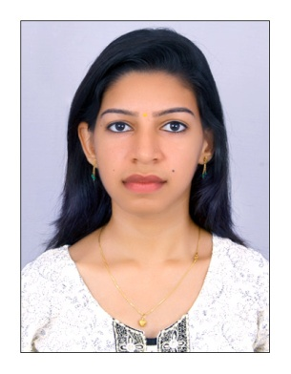

Name: Ms. Mary Nikitha Abraham. M
Contact No: +919847546760 Email: nikithaabraham74@gmail.com

Career Objective:

To seek a suitable position in a professionally managed organization where I can contribute my skills and be a part of the team that excels in work towards the growth of the organization.

Personality Traits:

- Dedicated, determined and diligent by nature.
- Possess effective communication skills with equally competent analytical and logical ability.
- Possess an ability to work in a team.

Educational Qualification:

QUALIFICATION | SCHOOL/COLLEGE | UNIVERSITY | YEAR OF PASSING | PERCENTAGE / CGPA
BCA | Amrita School Of Arts & Sciences,  Kochi. | Amrita Viswa Vidyapeetham. | 2016 | 6.9
+2 | Sahodaran Memorial Higher Secondary School, Cherai. | HSC | 2010 | 79.5
10th | Lady of Hope Anglo – Indian High School, Vypeen. | HSC | 2008 | 82

Professional Experience:
- Company: Einstro Technical Services Pvt Ltd, Chennai, Tamil Nadu
Position: OJT in HR (Talent Acquisition Executive)
Period: October 2017 to December 2017

- Company: Cadd Labs, Chennai, Tamil Nadu
Position: Business Development Manager
Period: June 2017 to September 2017

- Company: Wipro Technologies Limited, Chennai, Tamil Nadu
Position: Software Developer (Completed Training in AS400)
Period: December 2016 to March 2017

- Company: Apollo Tyres Private Limited
Position: Planning Production Trainee
Period: September 2016 to December 2016

Mini Project:

- Project Title: Classroom Allocation Management System.
- Software Used: Front end – ASP .NET.
Back end – SQL.

Main Project:

- Project Title: Online Pharmacy Management System
- Software Used: Front end – PHP
Back end - SQL

IT Skill Set:

- Programming Languages: C, C++, Java, J2EE, PHP, CSS, JSP, C# and ASP .NET.
- Operating systems: Windows XP, Windows 7, Ubuntu.
- RDBMS: Oracle-11g, SQL.
- Scripting Language: HTML, JavaScript, and XML.
Areas of Interest:
- Object Oriented Programming & Concepts – Java
- C# & ASP .NET.
- HR & Business Development Sectors.

Computer Knowledge:
- Experienced in MS Office Package.
- Aware about Organizational Behavior, Production Management, HR Aspects & Polices and Business Management.
Languages Known:
- English
- Malayalam
- Tamil
- Hindi
Hobbies:
- Driving
- Dancing
- Social Networking
Personal Details:
Date of Birth : 16/07/1992
Marital Status : Married
Religion : Christian
Caste : Latin Catholic
Nationality : Indian

I hereby certify that the above information is true and correct to the best of my knowledge and belief.

Mary Nikitha Abraham. M

