Mrs. NAIJUMOL.N
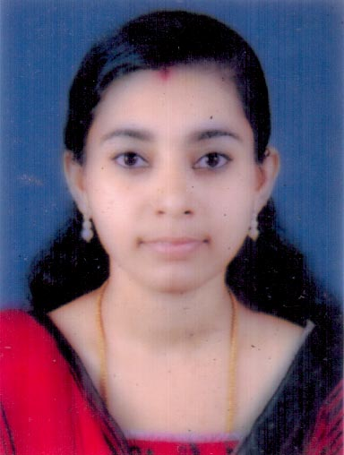
Phone No: 9496251519
Email: naijuvini@gmail.com

OBJECTIVE
To be associated with a progressive organization that gives scope to apply my knowledge and skills, and to be a part of team that dynamically works towards the growth of the organization.

ACHIEVEMENTS

- Was a part of the team that has managed more than 2000 patient’s of various complicated liver, biliary, pancreas & luminal related disease.

JOB RESPONSIBILITIES

- Evaluating the patients and summarizing the cases to the gastroenterologists & hepatalogists.
- Taking pre- rounds
- Write medications during rounds (after discussing with Physician)
- Case summary writing
- Order and interpret laboratory tests
- Obtaining patients consent for OPD procedure
- Providing routine medical management of inpatient care including ordering of diagnostic tests, labs, x- rays and nutrition.
- Assist IP & OP cases on admission basis
- Provide medical counseling to the patients and attenders.
- Prepare discharge summaries
- Help physician in filling Physician orders Progress notes, Consultation forms, forms needs for various examinations & finance clearance.
- Replying to the queries from patients about liver & GI related disorders.
- Filing insurance forms, preparing Medical Certificate and referring letters
- Assisting consultation in research activities
COMPUTER SKILLS

- Thorough knowledge about electronic medical records.
- MS- Office including Word, Power point, Excel

EDUCATIONAL QUALIFICATION

First class degree in MSc. AHS- Physician Assistant (Specialized in Gastroenterology) from Amritha College of Medicine.
- Institution – Amritha Institute of Medical Sciences and Research Centre, Cochin
- University – Amritha Viswa Vidyapeetham- Deemed University
- Course Duration (2009- 2013) – 3 Years with 6 months compulsory internship

COURSE DESCRIPTION
- First Year basic subjects including Anatomy, Physiology, Pharmacology, Pathology, Biochemistry and Microbiology. Followed by posting in General Medicine, General Surgery and Pediatrics.
- Second Year onward posted under the Gastroenterology Department AIMS Kochi
- Third Year completely in Gastroenterology Department
- Internship for six months in the department of Gastroenterology

PROJECT

The clinical utility of Anorected Manometry in anorectal disorders
Amritha Institute of Medical Sciences and Research Center, Cochin
BSc- Zoology
- Institution- C.M.S College Kottayam
- University – Mahatma Gandhi University
- Course Duration (2006- 2009) with Botany and Chemistry as Subsidiary subject

WORK EXPERIENCE
- As physician assistant in Gastroenterology Department at Amrita Hospital Cochin, Kerala (6 months internship).
- Worked as physician assistant in Al Shifa Hospital for Piles at Eranakulam, Kerala for 4 months.
- Worked as physician assistant in Muthoot Hospital Kozhenchery.
- Working as Physician assistant in Gastroenterology Department at Carithas Hospital Kottayam for3 years (still working).

PERSONAL DETAILS
Name : Naijumol N
Gender : Female
Fathers Name : K.Nazar
Marital Status : Married
Husband Name : Vineeth K.S.
Date of Birth : 03/04/1988
Nationality : Indian
Religion : Islam
Languages Known : English and Malayalam
Residential Address : Kayyalackal House
Kaduthuruthy P.O.
Kottayam Pin 686 604
Contact Number : 9496251519
Email ID : naijuvini@gmail.com

REFERENCE

Dr.Jino Thomas
DM in Gastroenterology
Department of Gastroenterology
Caritas Hospital
Thellakom p.o
Kottayam.
Ph No: 9744161026

Dr.Ismail Siyad
Professor & HOD
Department of Gastroenterology
Amritha Institute of Medical Sciences
Elamkkara P.O
Kerala, India, Kochi 682 041
Email: ismailsiyad@aims.aritha.edu

Brig.Dr.V.A.Narayanan
Department of Gastroenterology
Amritha Institute of Medical Sciences
Kochi
Email: narayananva@aims.aritha.edu

Dr.Shine Sadasivan
Specialist Gastroenterology
Dr.Joseph’s Speciality Clinic
Karama Dubai
&
Canadian Hospital
Abu Hail Rd
Dubai
Ph: 00971507073921

Dr.G.Rajesh
MD,DNB (Gastro), MNAMS
Associated Professor
Department of Gastroenterology
Amritha Institute of Medical Sciences
Elamkkara P.O
Kerala, India, Kochi 682 041

Dr.Geetha
Cilincal Professor
Department of Gastroenterology
Amritha Institute of Medical Sciences
Elamkkara P.O
Kerala, India, Kochi 682 041
Email: Dr.M.Geeths<123mgeetha@aims.amritha.edu

Dr.Preetham.H.S.
MD(Med) DM (Gastro)
Clinical Assistant Professor
Department of Gastroenterology
Amritha Institute of Medical Sciences
Elamkkara P.O
Kerala, India, Kochi 682 041

DECLARATION

I hereby declare that the above provided information are true and correct to the best of my knowledge.

Place: Kaduthuruthy Naijumol.N
Date : 01/01/2018

