CURRICULUM VITAE
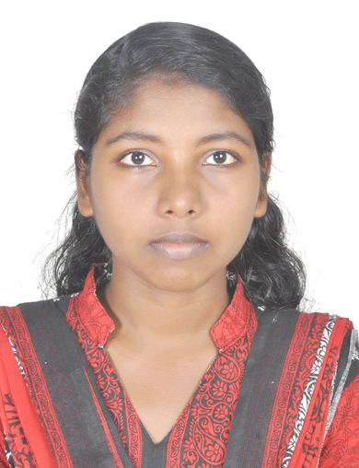

CHINNU PRAKASH

PARAPPARAMBIL (H)

S. PURAM P.O. KURICHY

KOTTAYAM, 686532

Chinnu1994prakash@gmail.com

Mob: 9048952054
JOB OBJECTIVE
I would like to work as a good Health Information professional, who is sincere and truthful to the job. I’ll utilize the maximum of my experience and skills for the development and progress of the organization.
EDUCATIONAL QUALIFICATION
COURSE | SCHOOL/COLLEGE | YEAR | BOARD/UNIVERSITY | PERCENTAGE
Master of applied science in Medical Documentation | School of Medical Education, Gandhinagar Kottayam | 2015-2017 | MG university | 66%
B.Sc. zoology model 2 aquaculture | Government college, kottayam, Nattakom | 2012-2015 | MG university | 75%
PLUS TWO | A.V.H.S.S. Kurichy | 2009-2011 | HSE board | 74%
SSLC | A.V.H.S.S. Kurichy | 2009 | SSLC | 79%

WORK EXPERIENCE
- 10 days training experience on St. Thomas Hospital Chethipuzha
- 20 days training experience on Lisie Hospital, Ernakulum
- 30 days training experience on RCC Thiruvananthapuram and W&C hospital Thycaud
- Two months project in General Hospital Changanacherry
SPECIALISATION
Master of Applied Science in Medical Documentation
INTERESTS AND ACHIEVEMENTS
I participated in a national seminar HIM INDIA INFO 2015 on 4&5 of December organized by Krishna Institute of Medical Science Ltd.
Did project work on the topic” Major lifestyle Diseases and the quality of lifestyle disease case records in General hospital Changanacherry” at General hospital Changanacherry.
PERSONAL OBJECTIVES
I utilize my whole potentials and skills to successfully do my career.
STRENGTHS
Excellent communication skills
Ability to work with a team
Positive approach towards all professional situations
Ability to handle the responsibilities of finishing assignments within a deadline
Excellent leadership skill
REFERENCE
Miss. Suma V. Madhavan
Head of the department of Medical Documentation
School of Medical Education, Gandhinagar
Email:sumavmadhav.docum@gmail.com
PERSONAL DATA
Name : CHINNU PRAKASH
Sex : Female
DOB : 23/05/1994
Marital status : single
Contact no. : 9048952054
Email id : chinnu1994prakash@gmail.com
DECLARATION
I hereby declare that the above facts and informations provided above are true and authentic to the best way of my knowledge and belief.
Thank you

