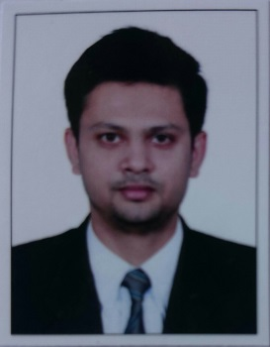 CURRICULUM VITAE

Personal Information:

• Name Dr. ALBIN BABY

• Date of Birth 02/02/1988

• Father’s name P D BABY

• Sex Male

• Marital Status Married

• Linguistic Profile Hindi, English, Tamil, Malayalam

• Nationality Indian

Religion Christian

• Address PAYYAPPILLY (H),
NAYATHODE PO,
ANGAMALY, PIN: 683572

• Contact no. 8086759918
- Mail ID : albin2rhyme@gmail.com

Education:
- Schooling done from Viswajyothi CMI Public School, Angamaly.
- Completed MBBS from Vinayaka Missions Medical College, Karaikal.
- Permanent registration from TCMC and Tamil Nadu State Council.

Work Experience-
- 1 year and 7 months work experience in department of cardiology at Samaritan Heart Institute, Pazhanganad as assistant to Dr. Koshy Eapen.
- 4 months work experience in department of Cardiology at Lissie Hospital, Ernakulam as assistant to Dr. Rony Mathew.
- 5 months work experience in department of cardiology at Unity Hospital, Kunnamkulam as assistant to Dr. Akhil P C.
- 8 months work experience as consultant in Corniche Poly clinic, Nedumbasserry.
- Occasionally worked as CMO in LF Hospital, Angamaly.
- Capable of handling CCU emergencies unsupervised.
- Keeping up to date with the latest treatments, medicines and medical developments in cardiology.
- Assisted cardiologist in non-invasive procedures (Angioplasty).
- Skilled in screening echocardiography.
- Proficiency in interpreting ECGs is excellent.

Key responsibilities handled:
- Responsible for emergency medical treatment.
- Dealing sympathetically with sensitive circumstances.
- Keeping up to date with the latest treatments, medicines and medical developments.
- Provided care to patients on hospital wards and outpatient clinics
- Worked in a pressurized environment and produce best result.
- Worked in home med units and camps.

Personal and Job Related Skills:
- Compassionate medical professional-A highly personable, competent, team spirited and able to handle stress with ease.
• Superior diagnostic skills and treatment planning and execution proficiency.
• Strong interpersonal and relationship building skills..
• Effective troubleshooting and problem solving skills in high pressure (life/death) environments.
• Clinically sound incorporating good decision-making skills.

Co-curricular activities:

• Attended yearly CME in all departments.
• Taken classes on various topics in medicine in college
• Under 18 state basketball player.
• Learned classical music for 6 years.
- Was an active member in church choir.

Motivation:
A team player who works in harmony with medical staff, administration, patient, and family members to ensure high quality medical attention consistent with organizational standard operating procedures.
I would like to serve an Institution where I can execute my skills and impart the knowledge I have acquired over my career with different hospitals.

