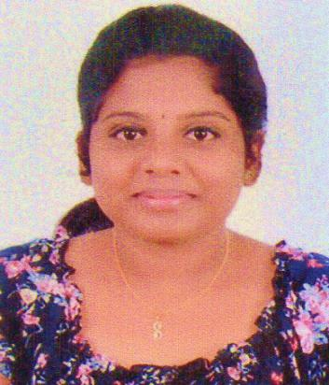  NITHYAPRIYA M.N.  Email id  nithyapriya1594@gmail.com  Permanent Address  Nithya,TRA-4,Mundakkal  East kollam,kerala  Pinvode : 691001  Mobile : +919497722274  :+918921822155  Personal Details  Father’s Name  Thankappan Gopalan  Father’s Occupation  Ex-Air Force Men  Mother’s Name  Nirmala Devi. D  Mother’s Occupation  House Wife  Date of birth : 15th May 1994  Sex  Female  Nationality  Indian  Marital Status  Single  Blood Group:- A+ | RESUME  CAREER OBJECTIVE  To get a good exposure, knowledge and showcase my ability & hard work at your esteemed organization.  ACADEMIC QUALIFICATION  Qualification and Name of the School/ College/ University Board/ University Year Pecentage obtained  Master Of Business Administration at Acharya Institute Of Technology ,Bangalore,Karnataka Visvesvaraya Technological University (VTU) 2017 (AUG) Completed awaiting for university certificates  B.com with Computer Application at Sree Narayana College Of Technology, Kollam,Kerala Kerala university 2015 70%  Higher Secondary (12th) At Sree Narayana Public School,Kollam,Kerala Central Board of Secondary Education (CBSE) 2012 60%  Secondary (10th) at Navdeep Public School,Kollam,Kerala Central Board of Secondary Education (CBSE) 2010 72%  EXPERIENCE  - HR intern at The Quilon Beach Hotel And Convention Centre  - TECHNICAL SKILLS  - Microsoft Office Excel, Microsoft Office PowerPoint, Microsoft Office Word.  - Internet Browsing  - ACADEMIC PROJECT  - B.Com  “Inventory Management “at Kerala Electrical And Allied Engineering Company Limited,Kundara,Kollam. It was to find out how inventory is managed to calculate the inventory
Linguistic Abilities  English  Malayalam | Turnover ratio of the company and its financial stability using MS Excel.  - MBA  “A Study On Job Stress And Its Effects On Employees” at Quilon Beach Hotel and Convention Centre, Kollam, Kerala This project focuses on the employees stress at different levels and its effects on them. I have given my views to overcome the problem of stress in the hotel.  ACHIVEMENTS  - Certificate in Cambridge International Entry Level Exams.  - “A” Grade in Advance MS Excel Certification Programme Conducted By Management Science Skill Development Center, AIT, Bangalore.  - Achieved prizes and certificates for participation in dance competition conducted during schooling.  PERSONAL SKILLS  - I am a good team player.  - Adaptability.  - Good communication skill.  - I am a good listener.  DECLARATION  I hear by solemnly declare that all the above furnished details are true to the best of my knowledge.  Yours Faithfully  PLACE: KOLLAM NITHYAPRIYA M.N.

