CURRICULUM VITAE
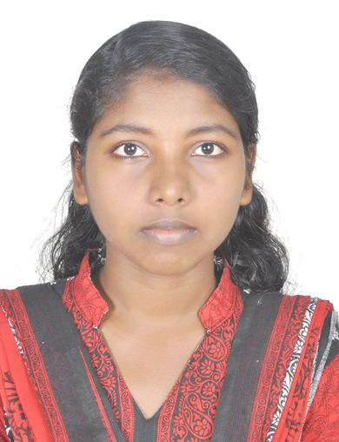

CHINNU PRAKASH

PARAPPARAMBIL (H)

S. PURAM P.O. KURICHY

KOTTAYAM, 686532

Chinnu1994prakash@gmail.com

Mob: 9048952054
Carrier objective:
To work as a medical records professional where I can utilise my experience and recently acquired knowledge. I would also like to further my professional development while working.
Personal statement:
I am looking forward to successfully fulfilling a long held ambition to become a qualified officer in Health Information Profession.
Educational qualification:
COURSE | SCHOOL/COLLEGE | YEAR | BOARD/UNIVERSITY | PERCENTAGE
Master of applied science in Medical Documentation | School of Medical Education, Gandhinagar Kottayam | 2015-2017 | MG university | 66%
B.Sc. zoology model 2 aquaculture | Government college, kottayam, Nattakom | 2012-2015 | MG university | 75%
PLUS TWO | A.V.H.S.S. Kurichy | 2009-2011 | HSE board | 74%
SSLC | A.V.H.S.S. Kurichy | 2009 | SSLC | 79%

Professional skill:
- Basic Computer skill
- Effective communication skills- oral and written
- Ability to relate to a variety of people of varying ages, backgrounds and cultures
- Equally effective working alone as well as within a team environment
- An ability to learn new tasks and information quickly
- Experienced and enjoy working as part of a team
- Equally confident working independently

Work experience:
- 10 days training experience on St. Thomas Hospital Chethipuzha
- 20 days training experience on Lisie Hospital, Ernakulum
- 30 days training experience on RCC Thiruvananthapuram and W&C hospital Thycaud
- Two months project in General Hospital Changanacherry

Specialisation:
Master of Applied Science in Medical Documentation
Interests and achievements:
Participated in a national seminar, HIM INDIA INFO 2015 on 4&5 of December organized by Krishna Institute of Medical Science Ltd.
Did project work on the topic “Major lifestyle Diseases and the quality of lifestyle disease case records in General hospital Changanacherry” at General hospital Changanacherry.

Interest:
- Enjoy reading
- Listening to music
- Travel

Personal data:
- Name : CHINNU PRAKASH
- Sex : Female
- DOB : 23/05/1994
- Marital status : single
- Contact no. : 9048952054
- Email id : chinnu1994prakash@gmail.com

Reference:
- Mrs. Suma V. Madhavan
Head of the department of Medical Documentation
School of Medical Education, Gandhinagar
Email:sumavmadhav.docum@gmail.com
- Mr.Georgekutty P K
Photographer, crime branch, Kerala
Ph.: 9447456548

Declaration:
I hereby declare that the above facts and information provided above are true and authentic to the best way of my knowledge and belief.
Thank you.

