BIO-DATA
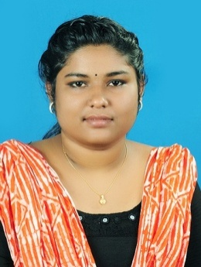
ALEENA JOSE
PUNNACKAL (H)
UDUMBANNOOR P.O.
THODUPUZHA, IDUKKI DISTRICT
KERALA, INDIA PIN: 685595
MOB : +917559836313, +919961724924
Email ID : aleena20894@gmail.com

OBJECTIVE
I am looking for a position that will give me an opportunity to enhance my skills and provide me to grow in helping the society by the maximum utilization of my conceptual knowledge, which I gained through my education and experience.

WORK EXPERIENCE

Chaitanya Institute for mental health, Pune. 01 July 2017 - 25 July 2017

Trainee

•Understand the signs and symptoms of different psychiatric disorders.

•Participate in individual counseling.

•Take awareness classes.

•Individual assessment.

•Group activities.

Sanjivani Psychosocial Rehabilitation Centre, Nedumkunnam, Kottayam
Trainee

•Study case histories.

•Conduct group activities.

•Journal discussions.

•Home visits.

•Conduct awareness classes and seminars.
01 March 2017 - 29 March 2017

Amala Institute of Medical Sciences, Trissur 31 Oct 2016 - 26 Nov 2016

Trainee

•Palliative home visits.

•Group activities.

•Conduct health awareness programs on different health days.

•Psycho social and financial assessment.

Mother and Child foundation, Painkulam 07 Apr 2016 - 10 May 2016

Trainee

•Analyze case histories.

•Conduct group activities and community programs.

•Take awareness classes.

•Conduct individual sessions with inmates.

EDUCATION

St. Joseph's College Moolamattom, kerala. 2015 - 2017
MSW. 76% (CGPA 3.02)

Medical & Psychiatry.

New Man College Thodupuzha, Kerala 2012 - 2015
BSC. 75%

Botany.

St.Joseph's HSS Karimannoor, Kerala 2010 - 2012
Plus Two 80%

Biology

St.Joseph's HSS Karimannoor, Kerala - 2010
SSLC 82%

SKILLS

•MS office
•Internet.

PERSONAL DETAILS

Name : Aleena Jose

D.O.B : 20-08-1994
Sex : Female
Religion : Christian Nationality : Indian

ACHIEVEMENTS

- Participated National Seminar and social work students’ meet in B.C.M. College Kottayam.
- Participated National Seminar on Person Centered Approach in Management of disabilities.
- Conducted a research on “Adjustment Of Tribal Adolescents”
- Participated in the social work research survey – “Cancer free Bio Kuttanad”

INTERESTS

•Medical and Psychiatric Social Work
•Teaching and School Social Work
•Counseling and Guidance
•Administration and Management

REFERENCES

1.Mr.Manu Kurian
Faculty of Social Work Dept. St.Joseph's College Moolamattom Phone:9846653196
2.Fr.Lijo Kochuveettil Faculty of Social Work Dept. St.Joseph's College Moolamattom Phone:9747407328

