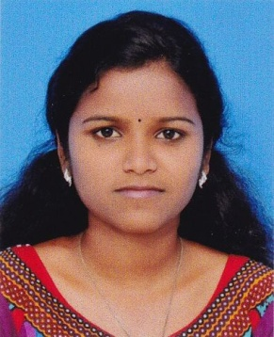
RESUME
Thiru nilathu House
Dhanya junction
Chalikkavattom
Cochin,
deepumrcochin@gmmail.com
Mob : 7558056026

Name : Anju Mohan
Name of father : Mohan
Age and Date of birth : 22, 28.01.1996
Marital Status : Single
Nationality : Indian
Mothertongue : Malayalam
Languages known : English, Hindi, Malayalam
Educational Qualification
- SSLC - Govt HS , Pooyappally, Kollam
- +2 - SMHSS, Kottara, kollam
- BSc Nursing, Bishop Benziger College of Nursing, Kollam (4 year),

