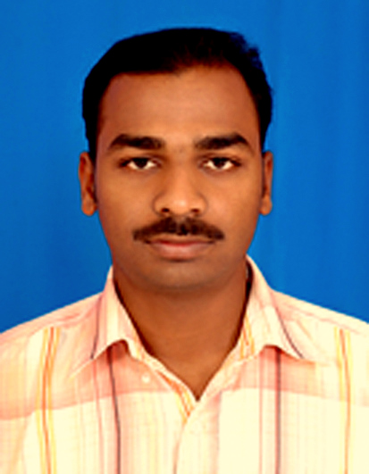

JOJO K T
KULANGARA HOUSE,
AKKARAPPADOM P O
VAIKOM, KOTTAYAM
KERALA, PIN: 686143,
Mobile No: +91-9562224745,
Email: jojokulangara@gmail.com

CAREER OBJECTIVE

More than 10 years of Operation and Maintenance experience in Oil/Gas Plant, Power Plants, Hospitals, Resorts etc

- From SEP 2017 to NOV2017 : Equate Plant Kuwait
- From JAN 2016 to FEB 2017 : Soma Kerala Palace Resorts Chempu
- From JUL 2013 to NOV 2015 : Qatalum Plant Qatar
- From APR 2012 to JUN 2013 : Kalathil lake Resorts Chemmanakary
- From SEP 2007 to FEB 2012 : Dhofar Power Company Oman
- From Mar 2005 to Mar 2006 : Brahmapuram Diesel Power Plant kochi
- From Jul 2004 to Mar 2005 : IndoAmerican Hospital Chemmanakary
Key performance areas.

- Maintenance of Generator and transformer, breakers, balance of plant auxiliaries, with includes, Drawing find out , and invent the failure of machine
- Electrical preventive maintenance and troubleshooting; contactors and circuit breakers, Motor control stations, etc.
- LV and HV switchgears Experience in preventive maintenance and breakdown maintenance and overhauling of rotating equipments. SF6 circuit Breakers, HT&LT Motors,etc
4. In Shutdown time annual maintance and Testing

Operation and maintenance of the followings:

  - Periodical testing of Electrical equipment and protection relays.
  - Fault diagnosis and the plant operating problems
  - 11kv MV cell maintenance
  - Transformers maintenance and their protection relay and controls
  - Maintenance and overhauling of LT motors up to 150KW
  - 11KV SF6, vacuum circuit breaker maintenance
  - Testing and maintenance of LV breakers and controls
  - L&T, Alstom make 415v LV switch gear and its protection controls
  - Electrically operated valve actuators and dampers (rotork auma)
  - UPS including battery charges, inverters
  - Plant lighting works
  - Cable fault finding and cabling

Personal Details

- Name of Full Jojo Kulangara Thomas

- Age & Date of Birth 33 years, 3rdMarch1984

- Fathers Name Thomas K.M

- Sex &Marital Status Male, Married

- Nationality Indian

- Religion& Caste Christian R.C

- Address Kulangara house,
Akkarappadom P.O
Vaikom, Kottayam dist
Kerala, India-686143
Tel :+91-9562224745

Educational & Technical qualification

- I T I in Electrical Engineering

- National Apprentice Certificate In Electrical Engineering

- Plus Two In Science Group

Training:
- Paid apprentice Training from100MW Brahmapuram Diesel Power Plant Brahmapuram Cochin,
- 6 Month training of Hospital Indo American Hospital Chemmanakary
- HSE Safey Orientation Training From Dhofar Power Company S.A.O.G

Declaration:

I hereby declare that the above information is true to the best of my knowledge and belief.

Date: 10/11/2017 Yours faithfully
Place: Vaikom JOJO K T

