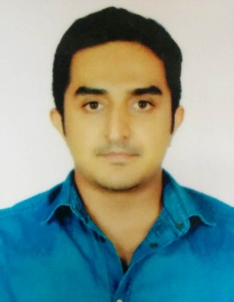
Allen Solomon
Kottarakara,Kerala,India
Contact:9995747603/dr.allensolomon@gmail.com

Career objective
Seeking a position in a growth oriented company offering Opportunity for advancement and professional development.

Work history
Believers Church medical college
- Junior doctor | Thiruvalla, KL | May 2016 - November 2016
Worked as a junior doctor in General Medicine department.
Mount Zion Medical College
- Junior doctor | Enadimangalam, KL | February 2016 - April 2016
Worked as junior resident in Cardiology Department

Education
MBBS :RAJAH MUTHIAH MEDICAL COLLEGEChidambaram, Tamil nadu | 2015
CBSE 12 TH BOARD: Girideepam Bethany central school Kottayam, Kerala | 2007
CBSE 10 TH BOARD: Girideepam Bethany Central School Kottayam, Kerala | 2005

Skills
- Sound knowledge of Medical terminology
- Charting and Documentation
- Good command over handling medical equipments
- Diagnostics
- BLS training
- Procedural Assistance and collaborative team player.
PERSONAL DETAILS
- Name:Allen.P.Solomon
- Father’s Name :P.G. Solomon
- D. O. B :25-01-1990
- Sex:Male
- Marital Status:Single
- Nationality:Indian
- Permanent Address:Peedikayil House,
(near)S.G College,
Pulamon P.O,
Kottarakara,
Kollam District, Kerala.
Pin : 691531
- Contact Number:9995747603
- Personal email:dr.allensolomon@gmail.com
Strengths:self confidence, and highly adaptable nature.
Hobbies:listening to music,jogging,football
Languages known:English,malayalam,tamil,hindi

DECLARATION
I hereby declare that all the information given above is true to the best of my knowledge and belief.
Place:kottarakara. DrAllen.P.Solomon
Date:5/02/2018

