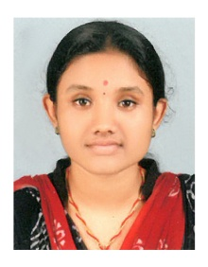
Curriculum Vitae
DEEPIKA DILEEP Mobile No: 9745705205
Email :deepikadileep2@gmail.com
OBJECTIVE
Seeking a challenging and growth oriented career opportunity in a reputed company where I can optimize my knowledge, technical skill and creativeness towards making significant contribution to the growth and development of the company and thereby improve and develop myself as responsible individual.
EDUCATIONAL QUALIFICATION
- B.COM with computer application – S N College ,Cherthala (2010 – 2013) , Affiliated to Kerala University.
- Senior secondary education – A.B.V.H.S.S., MUHAMMA(2008-2010) , Affiliated to higher secondary board of kerala.
COMPUTER SKILLS
- M.S. OFFICE
- TALLY
WORK EXPERIENCE
Company - Globesta Auditors and Accountants
Designation - Accounts trainee.
Period - 20th October 2014 – 30th October 2015
STRENGTH
- Excellent communication skills and hard working.
- Enjoy team work, projects and problem solving.
- Leadership quality, Interactive skills to co-ordinate work team.
- Motivated and having positive attitude.
- Achieving the goals set by company within timeline.

PERSONAL DETAILS
Father’s name : Dileep Kumar P.
Sex : Female
Date of birth : 11.05.1992
Marital status : Single
Languages known : English, Hindi, Malayalam, Tamil
Nationality : Indian
Passport no : N1665623
Hobbies : Gardening and Coin Collection
Address : Chilambisseri, Muhamma P.O.
Alappuzha, Kerala, INDIA

DECLARATION
I hereby declare that the above statements are true and correct to best of my knowledge and belief.
Date :
Place: Deepika Dileep

