CURRICULAM VITAE
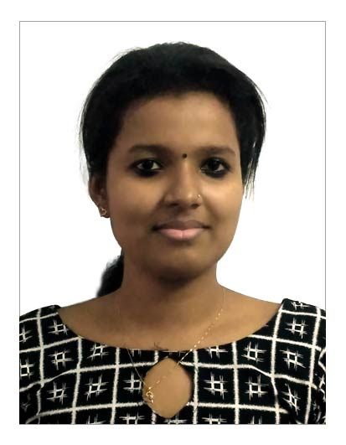
Haritha Pushpan
Thuruthiparambil House
Junior Janatha Road
Vyttila P.O
Pin Code -682019
Mob-8138847626
Harithapushpan357@gmail.com

CAREER OBJECTIVE
To work for an organization, where I can utilize my knowledge for the organization’s growth and move ahead in carrier by providing me interesting carrier opportunities and harness the best of my carrier.
PERSONAL PROFILE
Father’s Name : Pushpan P.A
Mother’ Name : Maduri pushpan
Date of birth : 16-12-1996
Sex : Female
Marital Status : Single
Nationality : Indian
Religion & Caste : Hindhu,Dheevara
Languages Known : English & Malayalam
PERSONAL STRENGTHS
Ready to take responsibility, Problem Solving Skill, Leadership skill
EDUCATIONAL QUALIFICATION
SL NO | COURSE | NAME OF INSTITUTE | YEAR
1 | B.com Computer Application | St.pauls college, kalamassery | 2017
2 | Plus Two | St.Theresa’s, Ernakulam | 2014
3 | S.S.L.C | C.K.C.G.H.S, Ponnurunny | 2012
4 | DCA | St.pauls college, kalamassery | 2017

Project Details
Title : Attitude of youngsters towards entrepreneurship
Description : It helps us to know attitude of youngsters towards Business
Duration : 3 month
Work Experience
Working as Accountant in Indeed Stericare from May 2017 to till date
DECLARATION
I hereby declare that the above particulars are true and correct to the best of my belief and knowledge.
Place :Janatha Haritha Pushpan
Date:

