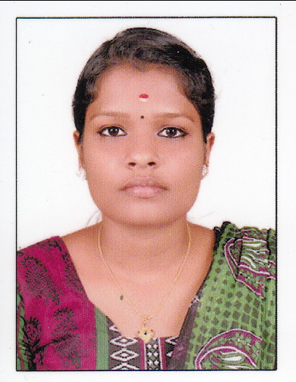

CURRICULUM VITAE
SURABHI.K
Kavungall House,
Mundakkal (PO), E-mail: surabhikavungal098@gmail.com
Malappuram(DT),
Kerala-673645. Phone: 9645243259 (Mob.) India

CAREER OBJECTIVE

A Promising position as a “ANAESTHESIA TECHNICIAN” in a reputed hospital.Where I can prove my extensive knowledge of this field.
PROFESSIONALEXPERIENCES

- Completed 6 months internship in MES medical college perinthalmanna.
- Worked as an Anaesthesia technician trainee from [29.2.2016-10.9.2017] at mes medical college perinthalmanna

MES MCH is a 600 bedded multi speciality hospital at perinthalmanna kerala.

ISO 14001:2004&9001:2008 certified with 15 modern OT’S

ACADEMIC QUALIFICATIONS

Course | School/College | Board/  University | Year of Passing
DIPLOMA IN OPERATION THEATRE& ANAESTHESIA TECHNOLOGY | MES institute of paramedical sciences,  perinthalmanna | Directorate of medical education | 2015
PLUS TWO | Gvhss omanoor | Boars of higher secondary examinatin | 2013
SSLC | K.K.M.H.S cheekode | Board of public examination | 2011

TECHNICAL QUALIFICATIONS
- Assisting anaesthesiologist for all type of anaesthesia
- Managing of pipeline gas supply
- Airway manangement
- Assisting for CVP catheter insertion
- Assisting IBP monitoring

ROLES AND RESPONSIBILITIES
- Creating the dosage of the medicine as per instruction of the anaesthesiologist
- Reassuring the patient before giving the anaesthesia to him
- Assisting anaesthesiologist during induction and anaesthesia procedure
- Preparation of anaesthesia traully,including medicine traully,workstation,and code blue boxes
- Giving scientific advice to the patient and his relatives about the all anaesthetic procedure
- Taking the signature on surgery and anaesthesia consents
- Monitoring the patients
- Positioning of patients
- Endotracheal intubation
- Anaesthesia ventilator management
- Basic life support

PROFESSIONAL EXPOSURE

Assisted anaesthesiologist for the following cases:-
- CARDIAC SURGERIES
- PAEDIATRIC SURGERIES
- GYNEC AND OBG
- ENT SURGERIES
- UROLOGY
- GENERAL SURGERIES
- NEURO SURGERIES
- PLASTIC SURGERIES
- GASTRO ENTROLOGY
- OPTHALMIC SURGERIES
- DENTAL AND MAXILLA SURGERIES
I AM also trained to assist the anaesthesiologist outside the operation theatre in areas like endoscopy,labour room[to prove labour analgesia],emergencies,etc
EXPERIENCE IN HANDLNG MACHINES&EQUIPMENTS IN OT

- Anaesthesia machine
- Breathing circuit
- Anaesthesia monitors
- Ventilators
- Defibrillators
- Infusion pumbs
- Pressure monitoring transducers
- Blood,fluid and body warmers
- Nerve stimulators and USG machine
- Types of endotracheal tubes,airways and LMS’S
.
PERSONAL PROFILE
Father’s name : RADHAKRISHNAN.K
Mother’s name :SUNANDHA.PE
Age :21
Date of birth :21.4.1996
Sex :FEMALE
Marital status :SINGLE

REFERENCES

- Dr.MANGESH SHENOY [MBBS,DA,MD]
Head of the anaesthesiology department.MES MCH perinthalmanna
PH;9400803264
- Dr.SHABEER ALI[MBBS,DA]
Cordinator of DOTAT MES MCH perinthalmanna
PH:9847216503
- Dr.SREEJITH[MBBS,MD,PDCC]
Cardiac anaesthesiologist MES MCH perinthalmanna
PH:9447190566

DECLARATION

I hereby declare that the above mentioned details are true to best of my
knowledge and belief.

THANKING YOU

DATE:
PLACE: Your’s faithfully

SURABHI.K

