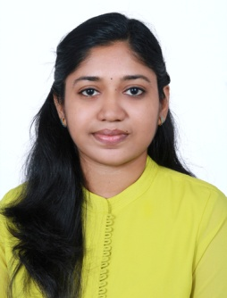

SruthiMadhusudanan

Date of birth:24-01-1990

Languages known: English, Hindi and Malayalam
Address:Aswathy (H), Kollenpadi, Irimpanam P.O, Ernakulam
91 9495279114

sruthmadhu@gmail.com

CAREER OBJECTIVE

Looking for position of Jr.Doctor in reputed hospital to learn about new skills and to gain more knowledge to enhance my personal growth.

EDUCATIONAL DETAILS
- Bachelor of Medicine & Bachelor of Surgery (M.B.B.S) from Cochin University of science and technology.
- HSC from CBSE with distinction.
- SSC from CBSEwithdistinction.
SKILLS
- Sound knowledge of medical terminology.
- Good command over handling the medical equipment’s.
- Good knowledge of Anesthesiology, and Surgery.
- Can handle the patients.
EXPERIENCE

- Worked as an Intern in Government medical college Ernakulum from Jan’2014 to Feb’2015.
- Worked as duty doctor in a 30 bedded hospital in Bellandur, Bangalore from Feb 2016 to July ‘2016.
- Worked as junior resident in the department of genitourinary surgery and renal transplantation at St Johns medical college hospital,bangalore from July 2016 to Jan ‘2017.

RESPONSIBILITIES HANDLED
- Assisting the senior doctor in checking the patients and assisting in surgery.
- Diagnosing the disease as per the symptoms in OPD.
- Observing and performing the examination of samples for disease diagnose.
- Learning the diagnostic methods and equipments.
- Periodically meeting the patients and observing their improvements and making reports.
- In case of emergency giving the basic treatment to the patients.
- Helping other medical staff in performing their duties.
INTERESTS
- Reading books.
- Travelling.
STRENGTHS
- Excellent theoretical knowledge.
- Excellent communication skills.
- Good knowledge of clinical practices and protocols.
- Ability to handle different types of patients.
- Flexible and adaptable.
- Extremely motivated towards career.
- Quick Learner.

