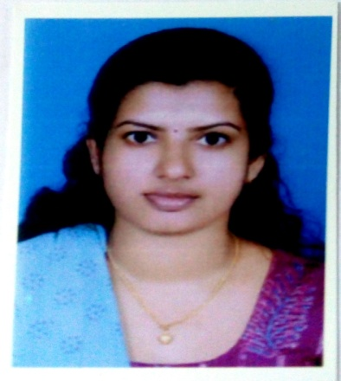
ALEENA MATHEW
D/O MATHEW K M
KUNNATHOTTEL (H)
NAKAPUZHA P.O
ERNAKULAM (DIS)
KERALA
PIN.686668
PHONE NO:8289819909
E-mail :mathewaleena29@gmail.com

CAREER OBJECTIVES
To apply my extensive knowledge of management principles and operations involved within the healthcare industry integrating education and performance management with all aspects of knowledge ,capital, human and quality management.

ACADEMIC QUALIFICATION
 | QUALIFICATION | INSTITUTION | NAME OF THE SCHOOL | YEAR
1 | S.S.L.C | ST.MARY'S HIGH SCHOOL NAKAPUZHA | ST.MARY'S HIGH SCHOOL NAKAPUZHA | 2007
2 | H.S.C | M.K.N.M.H.S.S KUMARAMANGALAM,IDUKKI | M.K.N.M.H.S.S.KUMARAMANGALAM,IDUKKI | 2009

PROFESSIONAL QUALIFICATION
COURSE | NAME OF THE INSTITUTION | YEAR | PERCENTAGE
B.SC NURSING(4YDC) | HOLY FAMILY COLLEGE OF NURSING THODUPUZHA EAST,IDUKKI | 2009-2013 | 64.1%

EXPERIENCE
I worked as a scrub nurse in cardio thoracic operation theatre in Apollo hospitals, Chennai, from 19 June 2014 to 05 January 2017.

HOSPITAL PROFILE
Apollo Hospitals is 650 bedded multi Specialty tertiary care centre has over 50 medical and surgical disciplines with specific area of interest in specializes in Cardiology , Nephrology, Urology, Orthopedics ,Gynecology, Pediatrics, Cardiothoracic Neonatal ICU, including critical care, Recovery and Operation theatre.
This hospital is tertiary referral centre in South East Asia .It is India's first corporate hospital and one of the first hospitals to get an ISO Certificate in the Region and Joint Commission International Accreditation (JCIA).It is the second best hospital in India.
OPERATING ROOM DETAILS:-
In Apollo we have 17 operating theatres including IVF(in vitro fertilization).We have the following surgeries performed in our operating room
1.CABG(OFF/ ON PUMP)
2.HEART TRANSPLANT
3.LUNG TRANSPLANT
4.MITRAL VALVE REPLACEMENT
5.AORTIC VALVE REPLACEMENT
6.ANEURYSM REPAIR
7.ATRIAL SEPTAL DEFECT CLOSURE
8.VENTRICULAR SEPTAL DEFECT CLOSURE
9.PATENT DUCTUS ARTERIOSUS LIGATION
10.CORRECTION OF TETROLOGY OF FALLOT
11.DOUBLE VALVE REPLACEMENT
12.REPAIR OF TAPVC AND PAPVC
13.BENTAL'S PROCEDURE
14.SUB VALULAR MEMBRANE RESECTION
15.LVAD,RVAD
16.ECMO(PERIFERAL,CENTRAL)
17.VASCULAR SURGERIES

EQUIPMENTS USED:-
1.HEART LUNG MACHINE
2.DEFIBRILLATOR
3.PULSE OXYMETERS
4.SYRINGE PUMP
5.FIBRILLATOR
6.SUCTION APPARATUS
7.CAUTERY MACHINE
8.ECG MONITOR
9.MICRO INSTRUMENTS
PROFESSIONAL EXPERIENCE
NAME OF THE HOSPITAL | DURATION | NO.OF YEARS
Apollo main hospitals ,Chennai | 19/6/2014 to 05/01/2017 | 2years and 6months

EXTRA COURSE UNDERWENT:-
COURSE | INSTITUTE | YEAR
BLS (BASIC LIFE SUPPORT) | APOLLO HOSPITAL, CHENNAI | 2014
ACLS(ADVANCED CARDIAC LIFE SUPPORT) | APOLLO HOSPITAL ,CHENNAI | 2016

PERSONAL DETAILS
Name :ALEENA MATHEW
Father's name :MATHEW K M
Date of birth :27.11.1991
Nationality :INDIAN
Place of birth :ANGAMALY
Contact no. :8289819909
Email :mathewaleena29@gmail.com
Marital status :SINGLE
Religion :CHRISTIAN RC
LANGUAGES KNOWN
Read and Write :MALAYALAM AND ENGLISH
Spoken :MALAYALAM AND ENGLISH

STRENGTH
-Confident and self motivated
-Can work under pressure
-Sincere and committed to the work undertaken

EXTRCURRICULAR ACTIVITY
-Reading books to keep knowledge update
-Sports

DECLARATION
I hereby declare that the above said facts are true to the best of my knowledge
thanking you
yours faithfully
ALEENA MATHEW

REFERENCE
1.MRS.VIJAYAKUMARI
NURSING OFFICER(CARDIOTHORACIC OPERATION THEATRE)
APOLLO MAIN HOSPITAL, CHENNAI

2.DR.M.R.GIRINATHGIRINATH
CHIEF CARDIO THORACIC SURGEON
APOLLO MAIN HOSPITAL,CHENN

3.DR.L.F.SRIDHAR
SENIOR CONSULTANT CARDIO THORACIC SURGEON
APOLLO MAIN HOSPITAL,CHENNAI

