CURRICULUM VITAE
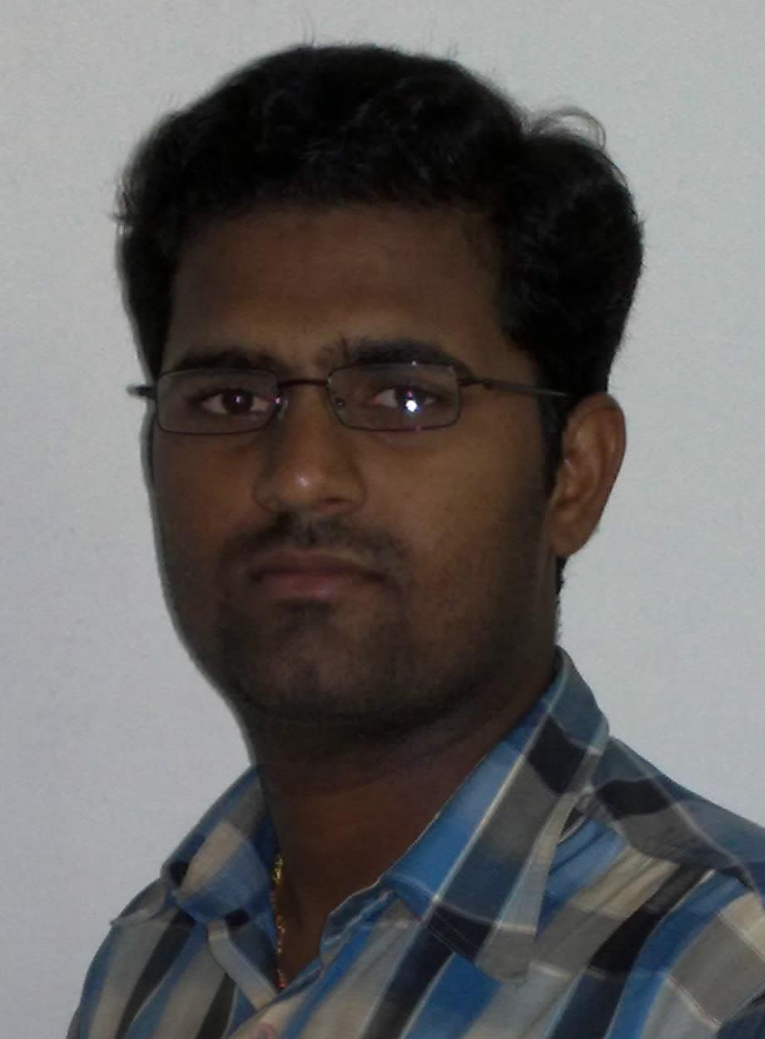

Dr.NISHANTH P.KURIAN
Anjali Parackal House
Pulamon P.O
Kottarakkara
Kollam (Dist) Mob: +919447327124
Kerala, India. +917736608986
E-mail:drnishanthpkurian@gmail.com

Career Objective:-

I am an orthopedician keen to join a renowned Medical organization to build a solid base for further updating in skills and knowledge as a surgeon. I have specialized in Shoulder and sports medicine. I believe I am a good clinician first, leading into, a future Shoulder & Knee specialist.

Qualities:-

Disciplined hard working and confident. Excellent training under veteran Orthopedic Surgeons for three and half years post residency in a high patient load set up. Experience and ability to manage trauma cases, arthroplasty and arthroscopy focusing on Shoulder.

Professional Qualification:-

Qualification | Institution | Year
MBBS | Govt. Medical College, Thiruvananthapuram | 2003-2008
Internship | Govt. Medical College, Thiruvananthapuram | 2008-2009
MS Orthopedics | Govt. Medical College, Thiruvananthapuram | 2011-2014
Junior Consultant | SUT Hospital Trivandrum | 2014 August – 2015
Fellowship in arthroplasty | Apollo Specialty Hospital  Bangalore | 2016 Feb – 2016 July
Lecturer in Shoulder and Sports medicine | Deenanath Mangeshkar Hospital Pune | 2016 July – 2017 December

Experience:

I was selected to complete my graduation and post-graduation from Govt Medical College Trivandrum. After finishing residency in orthopedics, I had a rare privilege to work as a junior consultant in SUT Hospital Pattom, Trivandrum a leading medical center under Prof K C Gopalakrishnan FRCS, MS Ortho for one year.
I did my AO basic course in 2015.
This was followed by a Fellowship in Arthroplasty at Apollo Specialty Hospital, Bangalore under Dr Sanjay Pai, MS Ortho. It’s a well-known arthroplasty arthroscopy center with a turnover of 1000-1500 arthroplasty cases per year.
Currently I am under the tutelage of Dr Ashish Babhulkar from July 2016. Although I am tasked a lecturer in Dept. of Shoulder and sports medicine Deenanath Mangeshkar, My work profile is diverse. This is a shoulder & Sports injuries center with a high volume of cases covering every surgical variety. Due to the academic and teaching status, I had to double up as research coordinator and planner for surgeries. At this center we are focused on shoulder with 150-200 shoulder opd patients and 15 -25 shoulder surgeries per week.
I have been selected for My Korean Fellowship 2018 Jan to March 2018.

Research Work

1) Functional outcome of Floating Knee Following Surgical Management

2) Clinicopathoradio discussion Case Presentation in - Insight 2015 Trivandrum
3) Arthroscopic Latarjet A retrospective study on graft and screw position-
IASCON Jaipur 2017
Academic Conference of Asian shoulder and Elbow Surgeons 2017
4) One-staged bilateral arthroscopic rotator cuff repair - a retrospective study –
WIROC 2016 poster & ACASEA 2017 Poster

Publications

- Nice Knot and Surgical Knot Security in Reverse Shoulder Arthroplasty with Different High Strength Suture Materials - An In Vitro Mechanical Study
Dhrumil M Patel , Ashish S Babhulkar , Nishanth P Kurian
European Journal of Sports & Exercise Science, 2017, 5 (2): 16-22
2) Arthroscopic Management of a Rare Case of Melioidotic Septic Arthritis of the Ankle in a New Endemic Area on the Southwest Coast of India - A Case Report
Ayyappan Vijayachandran Nair, DNB(Ortho), Vidya Menon, MD, Chandrababu K. Kumaran, MS, and Nishant Kurian, MS
THE JOURNAL OF BONE AND JOINT SURGERY, INCORPORATED VOLUME 7, NUMBER JULY 12, 2017

Ongoing Research

- Effectiveness of Rotator Cuff Recruitment on Pain And Functional Activity in patients with rotator cuff pathologies
Dr Renu Londe, Dr Nishanth P Kurian, Dr Snehal Deshpande, Dr Ashish Babulkar
- Hydrodialatation in Adhesive capsulitis – A Randomized Control Study
Dr Vishnu Unnithan, Dr Nishanth P Kurian, Dr Prateek Patil, Dr Ashish Babulkar
- Arthroscopic AC joint Reconstruction – A retrospective Study
Dr Vishnu Unnithan, Dr Nishanth P Kurian, Dr Prateek Patil, Dr Ashish Babulkar
- Microfracture in rotator Cuff repair – A randomized Control Study
Dr Arun GR, Dr Nishanth P Kurian, Dr Vishnu Unnithan, Dr Ashish Babulkar

- Study of Effects of Version of Prosthetic Humeral component on the ranges of motion in patients undergoing reverse shoulder arthroplasty
Dr Prateek Patil, Dr Nishanth P Kurian, Dr Ashish Babulkar

- A Randomized controlled comparison of various stretching procedures for posterior shoulder capsule tightness
Dr Snehal Deshpande, Dr Nishanth P Kurian, Dr Renu Londe, Dr Ashish Babulkar

References

- Dr Ashish Babhulkar – 09822218550
- docshoulder@gmail.com
- Dr Sanjay Pai - 09845012885
- Pai_sanjay@rediffmail.com
- Dr KC Gopalakrishnan – Sir is No More
Dr Subin Sugath – Consultant Ortho oncology Surgeon, Aster Medicity, Kochin Kerala
- Assistant To Dr K C Gopalakrishnan
- 9847008580
- bhaskarsubin@gmail.com

Seminars & Conferences Attended

- AO Basic Course 2015
- Pune Knee course 2017
- Shoulder Conclave Pune 2017
- Indian Arthroscopy Society Annual Conference 2016
- WIROC Bombay 2016
- Ganga arthroscopy Conference 2016
- Cadaver Work shop in shoulder Arthroplasty 2017, MS Ramaih Banglore
- Cadaver workshop knee scopy Ramaih Hospital, Bangalore.
- Cadaver workshop shoulder scopy Ramiah Hospital, Bangalore.
- Cadaver workshop knee and shoulder scopy Amritha Medical College Eranakulam
- SESI Thrissur 2015
- SESI Kumarakom 2017
- Ranawat Arthroplasty Conference 2016
- Depuy Basic Arthroplasty course 2015
- Basic hip arthroplasty course 2015 Trivandrum
- Primary complex TKR cme 2015
- Amrita Spine Course 2014
- ARTHROCON 2013, Chennai
- TOPIC 20012 ,2013,2014 Trivandrum
- OASIS Adult Hip Course ,Trivandrum
- Basic Knee Arthroscopy
- Lourdes Primary Hip Arthroplasty Workshop
- Cure – Ponseti Method of Clubfoot Management
- Basic Ilizarov Course 2013 Calicut
- Basic Illizarov Course 2015 Calicut
- Limb Deformity Correction Course 2013 ,Chennai
- Dictum 2012 – Perthes Disease
- Basic hip arthroplasty course 2015 Trivandrum
- Insight 2013 , Trivandrum clinicopathoradio meeting
- Insight 2015 , Trivandrum clinicopathoradio meeting
- Foot and ankle symposium 2015 Kochi
- IASCON Kolkata 2016
- IASCON Jaipur 2017
- ACASEA 2017

.
Personal Details:-

Date of Birth : 31.05.1985
Gender : Male
Nationality : Indian
Wife : Dr Nishy Mathew, MD General Medicine
Kids : George N Kurian (3 years)
Johann N Kurian (1 Year)

Place: Trivandrum
Date: 15.01.2017 NISHANTH.P.KURIAN

