CURRICULUM VITAE

Name: REMYAMOL.K.S
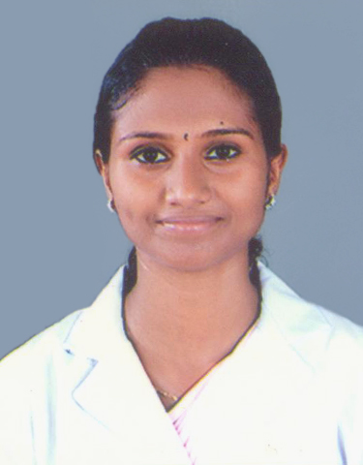
Paste your Photo Here

Phone No.: 9207202314
E- Mail: remya25.praveen@gmail.com

CAREER OBJECTIVE

To reach position that will build as my skills and experience that allows me scope for upward movement in nursing profession.

PERSONAL DETAILS

Fathers Name : K.T.SUDHAN
Date of Birth : 30th May 1987
Age : 29
Nationality : Indian
Gender : Female
Marital Status : Married
Name after marriage : REMYAMOL.K.S
No of Children & Age : N A
Religion : Hindu
Height : 154 cm
Weight : 45 kgs
BMI : 18.98
Present Address : Thozhuthungal House,
Vilangu (P.O),Vilangu Kara,
Ernakulam, Pin:683561
Permanent Address : Kunnumpurath House,
Ericadu,Puthuppally(P.O),Kottayam,Pin:686011.
Languages Known : English,Malayalam and Kannada
Hobbies : Cooking and Gardening
PASSPORT DETAILS

Passport No : L 6558366
Place of Issue : Cochin
Date of Issue : 08/01/2014
Date of Expiry : 07/01/2024
IELTS SCORE (SPECIFY EACH & OVERALL)

Writing 6.5 listening 5.5 Speaking 5.5 reading 5.5 Over all 6

TOTAL EXPERIENCE : 5 years and 10 months

EXPERIENCE AFTER REGISTRATION – 5 years and 6 months

EDUCATIONAL QULIFICATION
Course/Exam Passed | Board/University | Period of Study | No. of years of Study
Secondary School Leaving Certificate | Board Of Public Examination,Kerala | 2002 | 1
H.S.C. (Science) | Board Of Higher Secondary Examination | 2002-2004 | 2
GNM Nursing | Karnataka State Diploma Nursing Examination Board | 2005-2007 | 3
Post BSc | Rajive Gandhi University | 2011-2016

REGISTRATION STATUS
Nursing Registration | Registration No | Registration Date
The Karnataka State Nursing Council | 104774 | 15/05/2008
Kerala Nurses And Midwives Council | 66866 | 21/01/2011
Karnataka State Nursing Council | 20556 | 24/03/2017

EXPERIENCE SUMMARY
Name of the Employer | Bed Capacity | Position held |  | Area of Exposure | Duration | Achieve years
Shri B.M.Patil Medical College,Hospital and Research Centre,Bijapur | 1500 | Bond Staff |  | Medical ICU | 8 months | 2008
Medical Trust Hospital,Cochin | 750 | Staff Nurse |  | Neurology ICU | 15 months | 2008-2010
PVS Memorial Hospital,Cochin | 250 | Staff Nurse |  | Medical Surgical Ward | 1 year | 2010-2011
Medical Trust Hospital,Cochin | 750 | Staff Nurse | Medical ICU |  | 20 months | 2011-2013
Ministry of Health, Maldives |  | Registered Nurse |  |  | 1 Year  2 months | 2015- 2016

MEDICAL EQUIPMENTS AND MACHINES OPERATED

1. Glucometer
2. Pulse Oxymeter
3. Patient Monitors
4. Infusion Pump
5. Ventilators
6. Defibrillator
7. Nebuliser

DUTIES & RESPONSIBILITIES

1. Admission and discharge of patients
2. Maintain personal hygiene and comfort of patients
3. Provide nutritional need of patients
4. Daily living activity
5. Maintain clean and safe environment
6. Assist the doctor on their routine rounds
7. Administration of medicines
8. Preparing patients and article for nursing procedures
9. Recording vital signs
10. Maintaining intake and output chart
11. Help doctors in diagnosis and treatment
12. Observing changes in patient conditions, recording and reporting to the doctors
13. Rehabilitation

NURSING SKILLS & PROCEDURES

1. IV Cannulation
2. Ryles tube insertion
3. Foleys Catheterzation
4. Suctioning
5. Blood Transfusion
6. Stomach Wash
7. Extubation
8. Bowel wash
9. Bladder wash
10. Removal of Central Catheter and Suture
11. Wound Dressing
12. Health Education

REFERENCES

1. Mrs. Icy, Nursing Superintendent, Medical Trust
Hospital, Ernakulam.
2. Dr. Radhakrishnan Nair , Neurologist, Medical Trust
Hospital, Ernakulam.

DECLARATION

I do hereby declare that all the above furnished information are true to the best of my knowledge and be

Yours Sincerely

REMYAMOL.K.S PLACE: COCHIN
DATE :

